**INVENTORY MANAGEMENT**

Date of Supply = Inventory on hand/Avearge daily usage

Annual ordering cost = No of order x multiplied by cost per order

Economic order quantity =sqrt(2AS/ic)

Ques1-What is Kanban?

Ans-It refers to card or signals.

Ques2-What are the two rules pertaining to the controls based on ABC classification?

Ans- Have Plenty of low-value items

Focus control effort on A itmes

Ques3-What are the various components of item cost?

Ans- Purchase Items,Direct Labor, Factory overhead

Ques4- What does Lot-for-Lot signify?

Ans- It means that one should order exactly what is needed for the next period.

Ques5- What is the Aim of ABC inventory control?

Ans- Aim of inventory control is application of different level of control based on the relative importance of items.

Ques6- What does MRO mean?

Ans- Maintainance reapir and operating

Ques7- Name some of the goals of inventory management.

Ans- Create a buffer against uncertainties in supply and demand

Build up seasonal demand for promotional sales

Ques8- What are inventory cost?

Ans- Costs related to storage and maintaining its inventory over a certain period of time.

Ques9- How do you calculate Days of Supply?

Ans- Inventory on hand/Avearge daily usage

Ques10- How do you mathematically respresent EOQ>

Ans- Economic order quantity =sqrt(2AS/ic)

**WAREHOUSE MANAGEMENT**

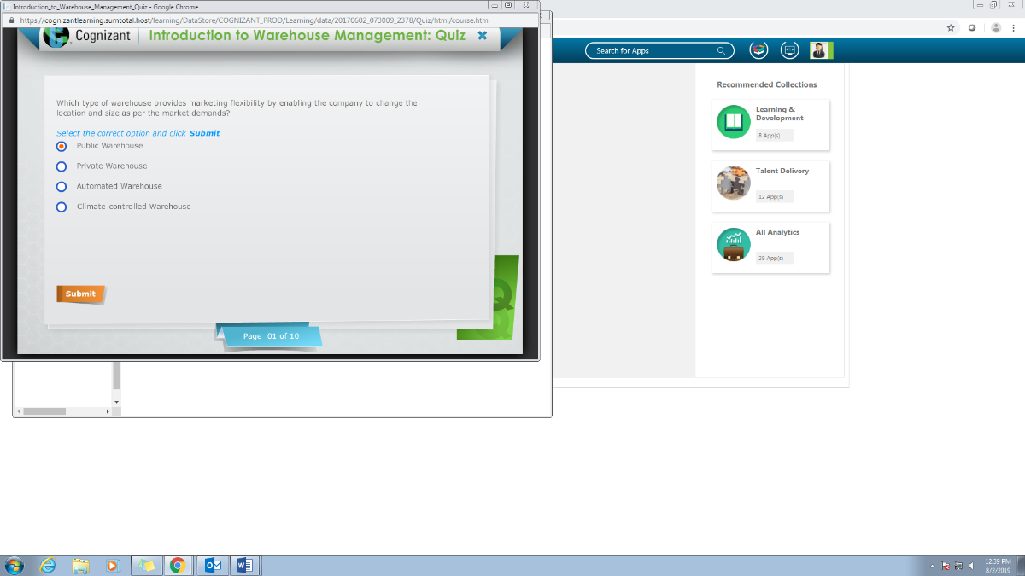

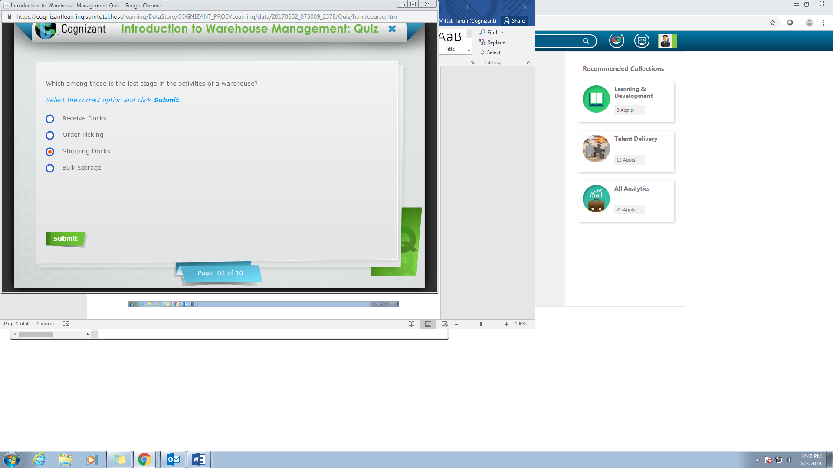

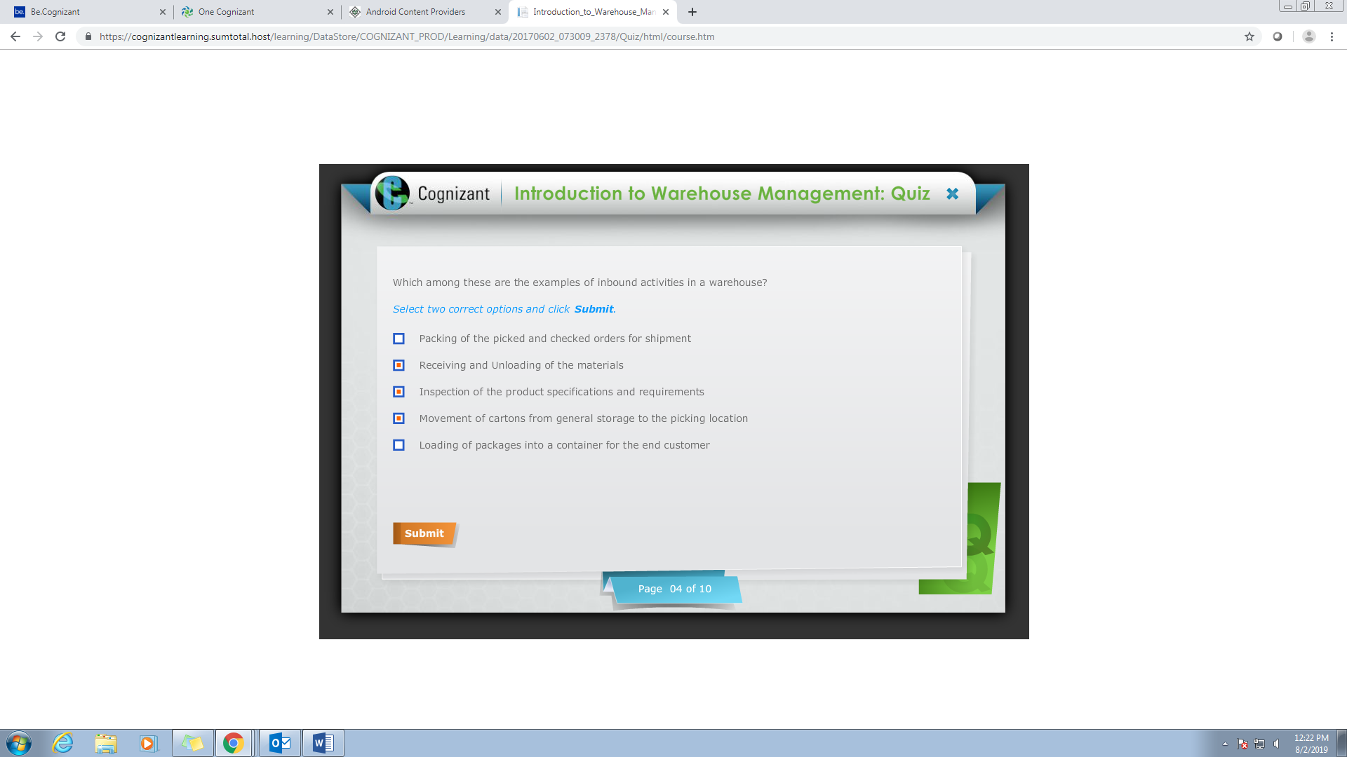

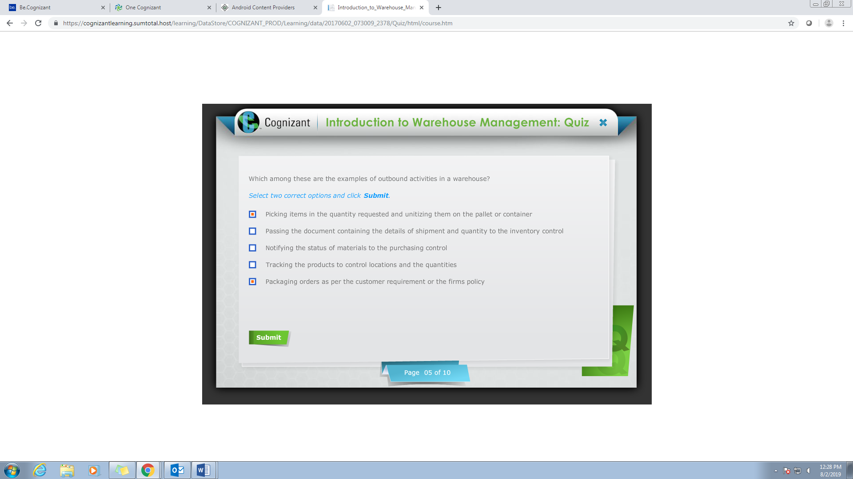

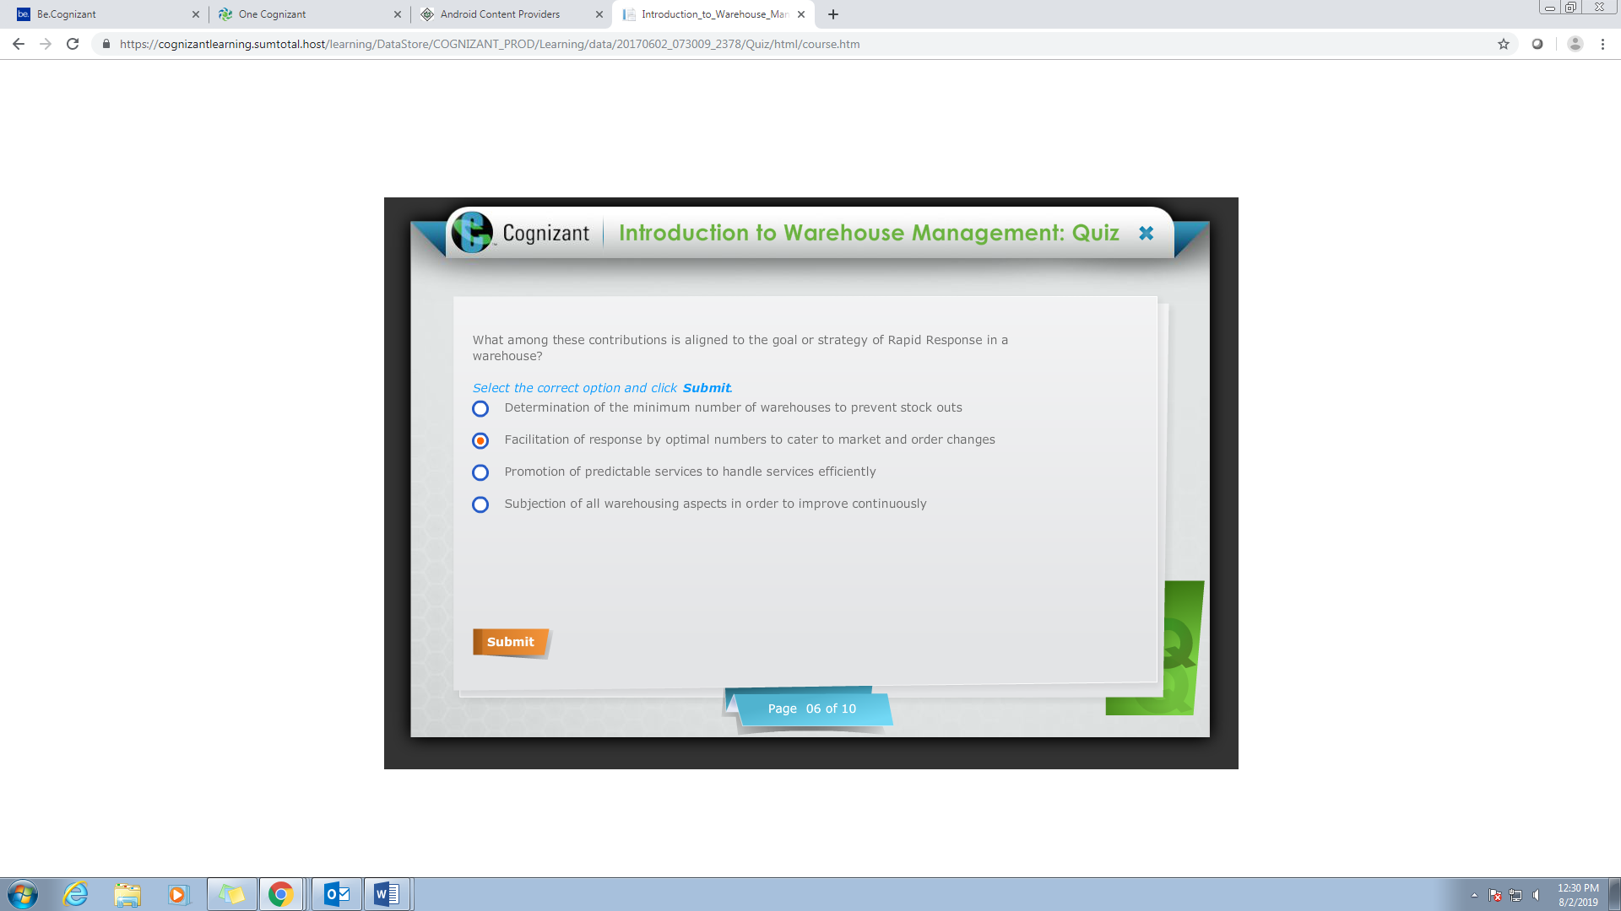

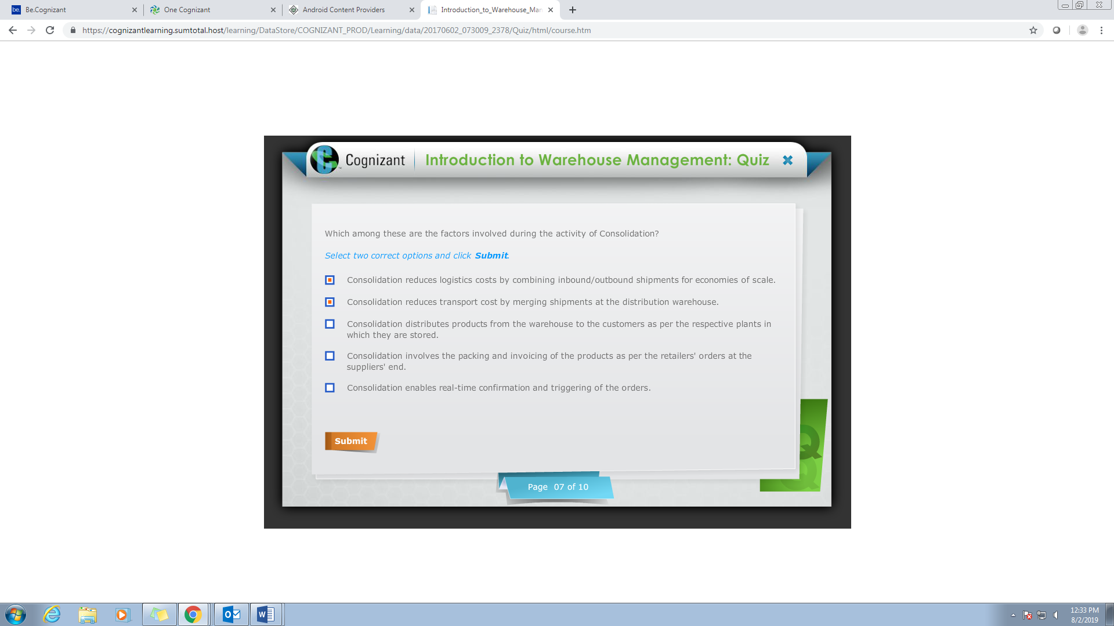

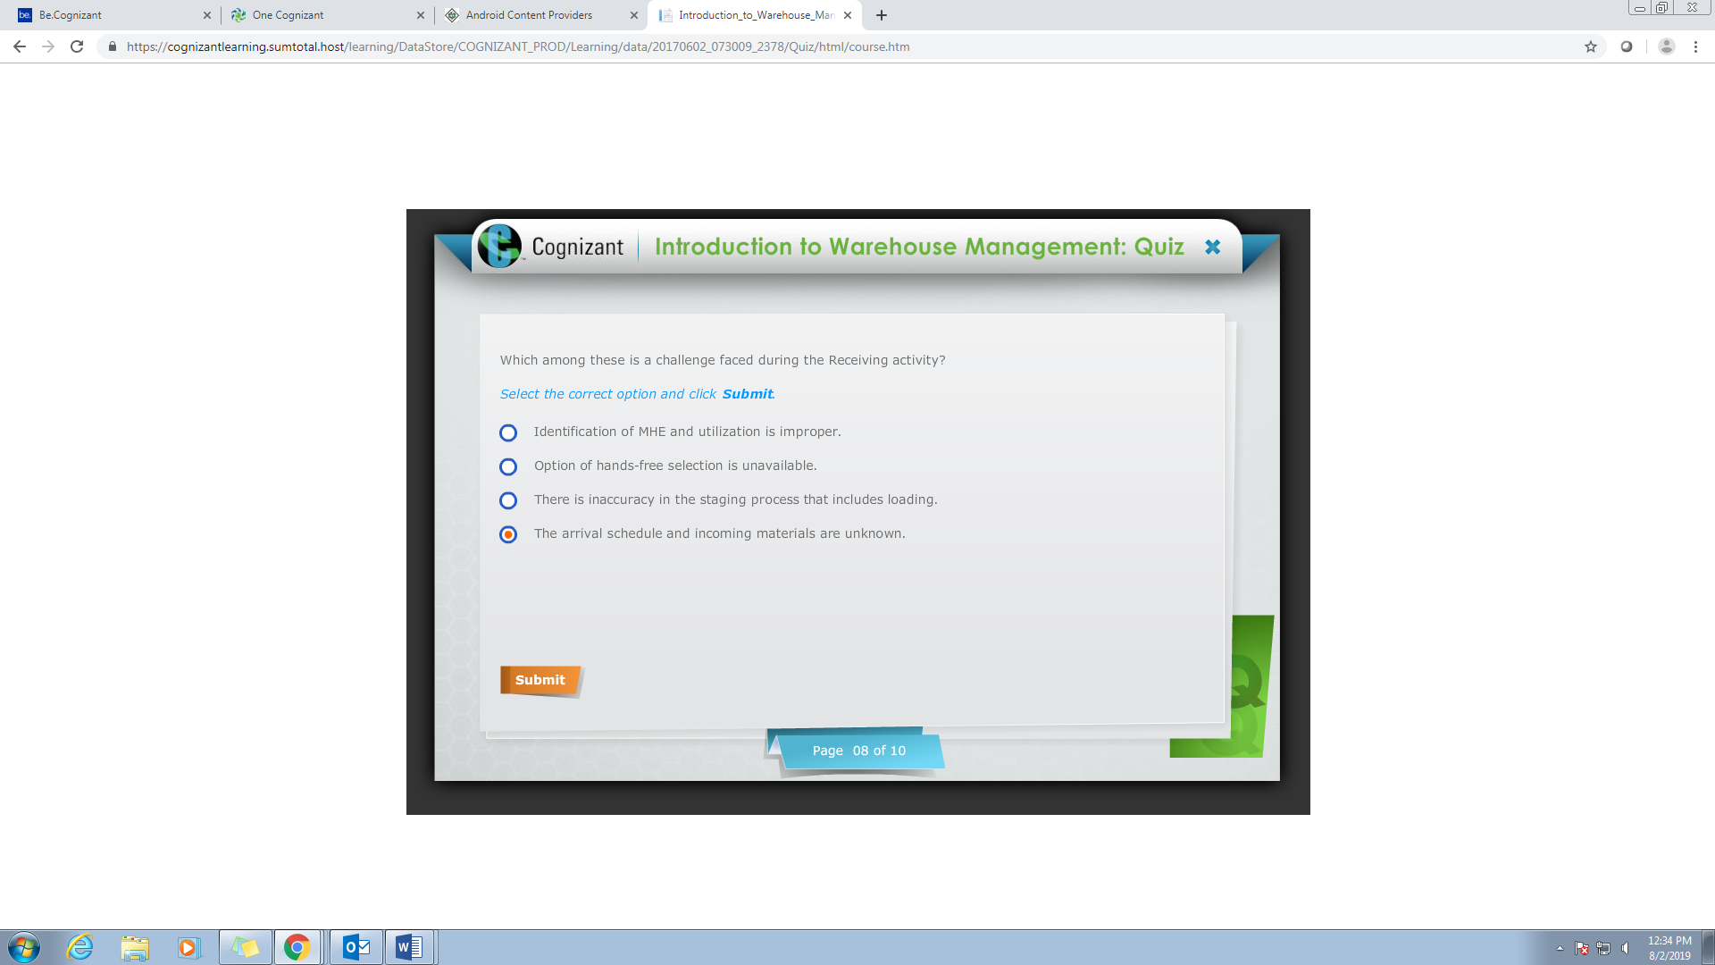

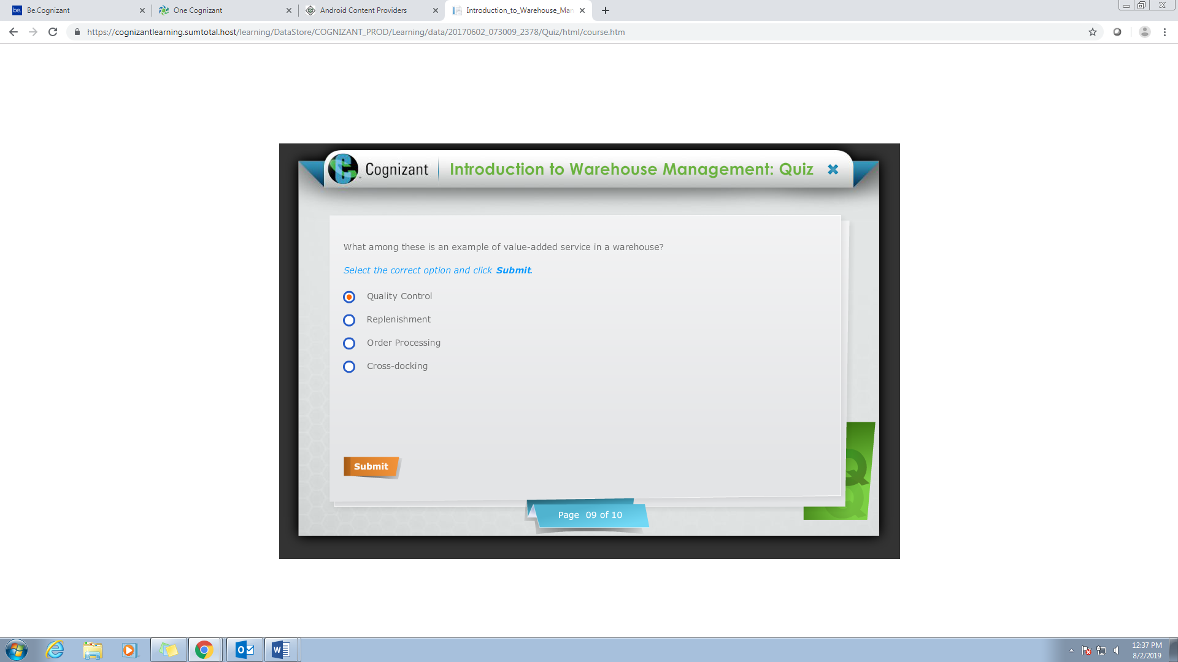

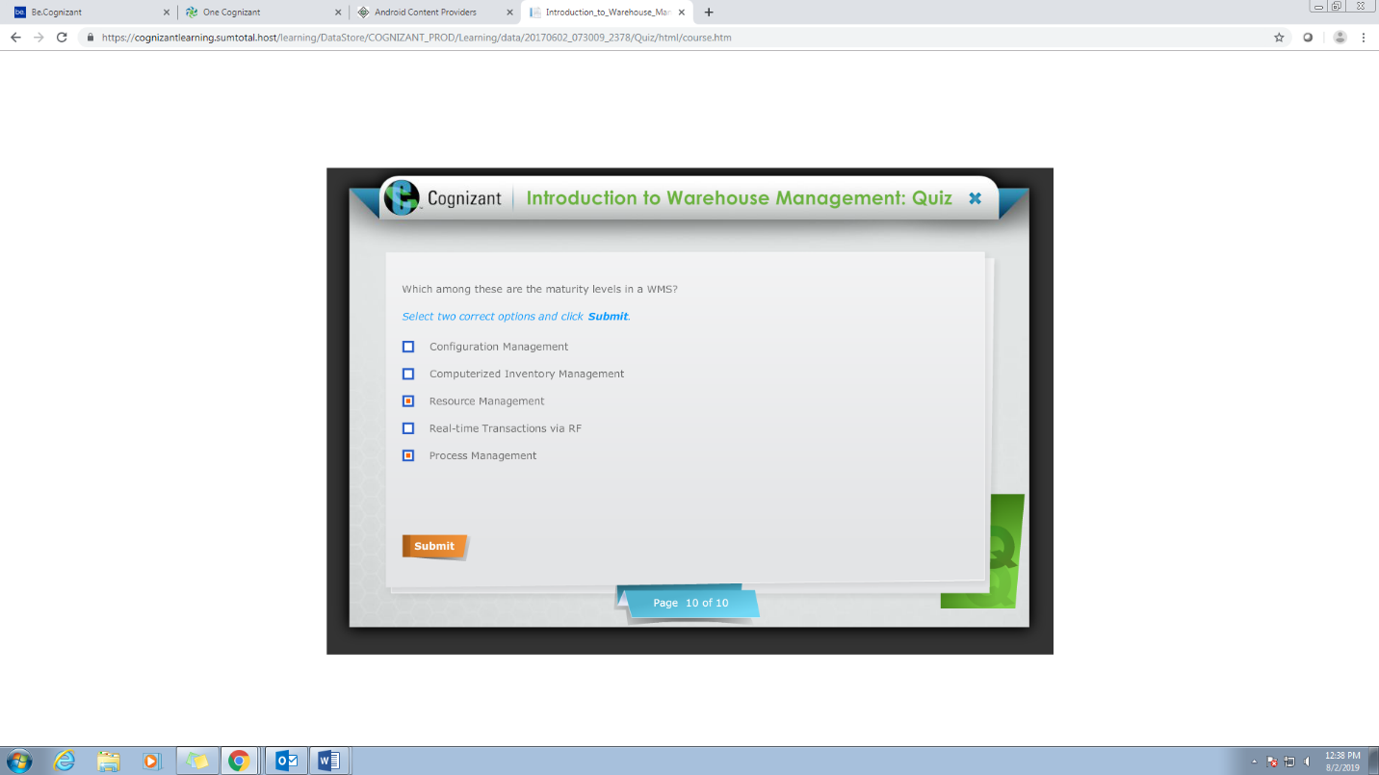

**DEMAND MANAGEMENT**

**Q1**

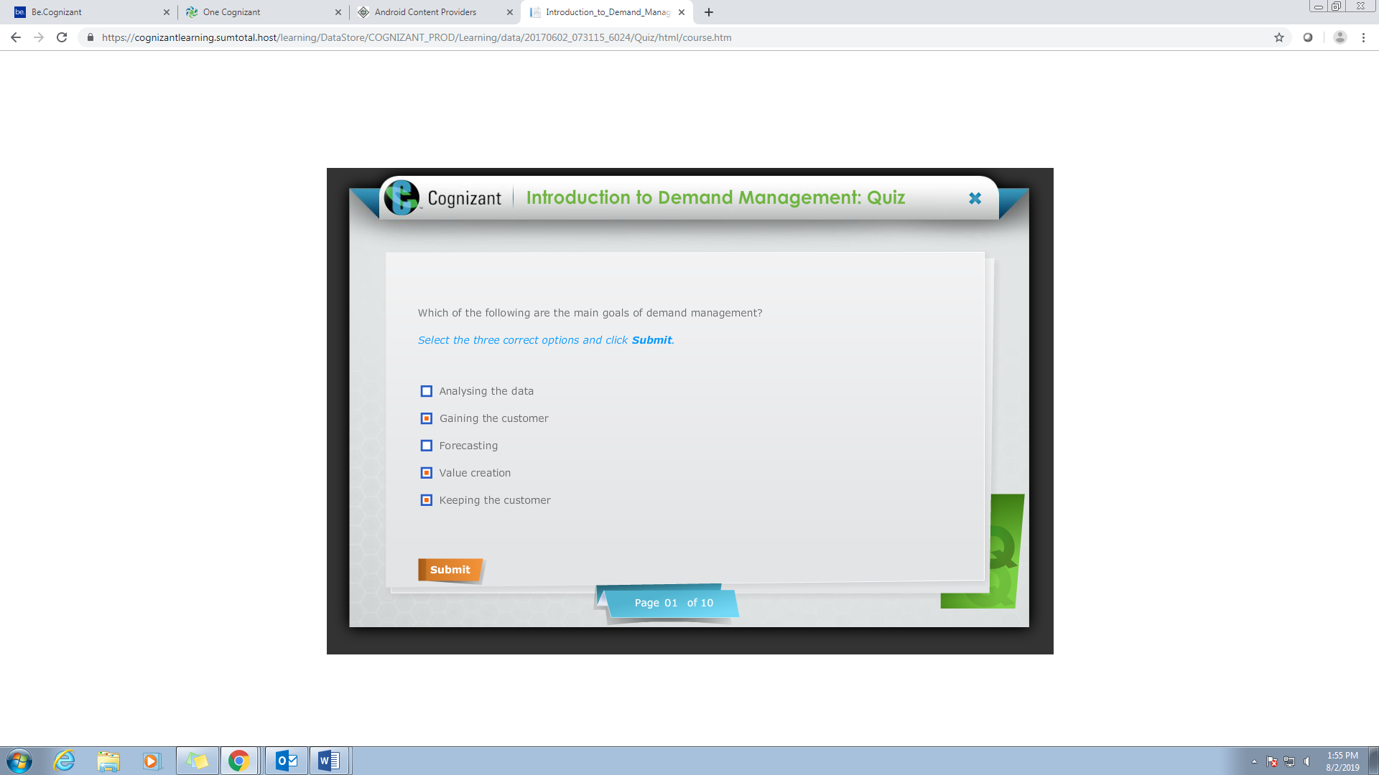

Q2

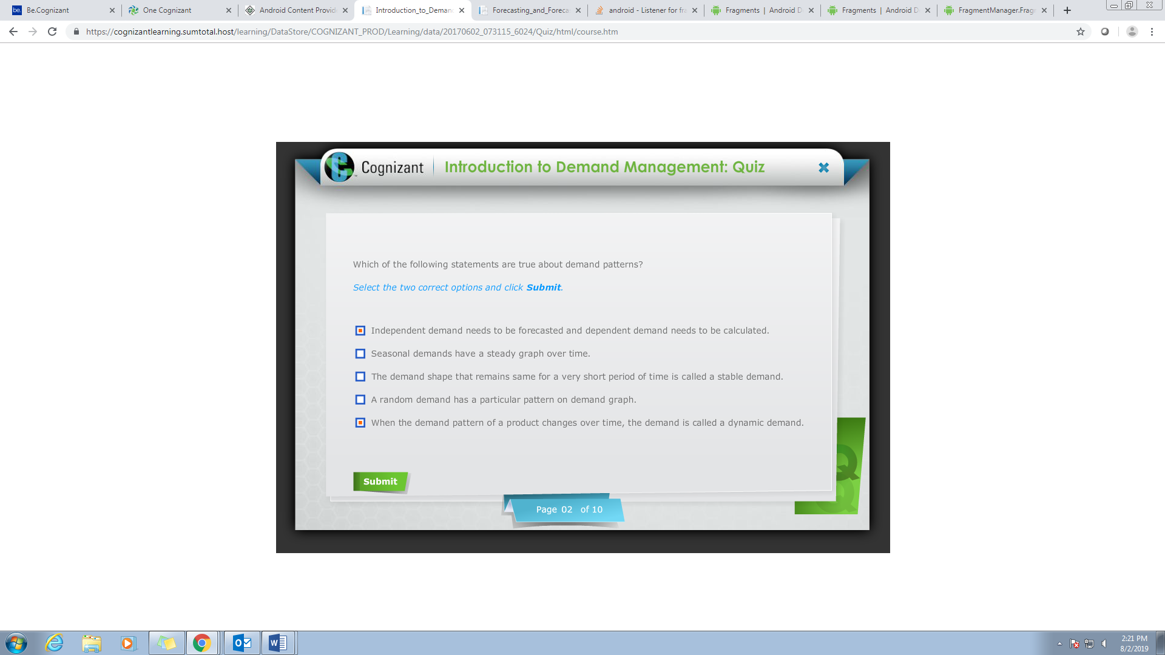

Q3

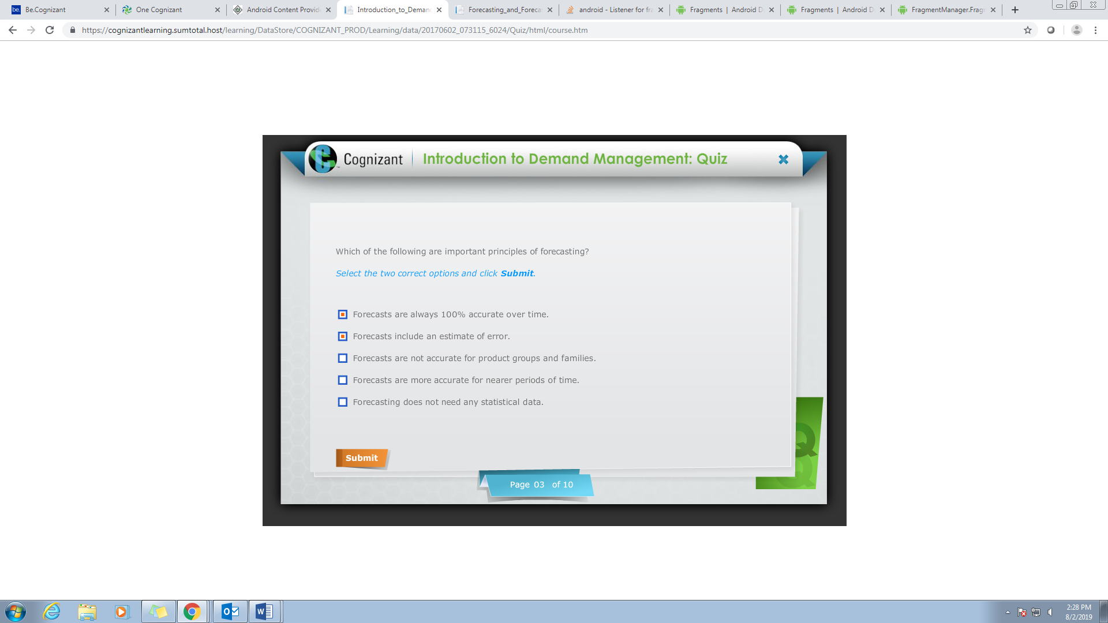

Option 4 ,option2 are correct

Q4

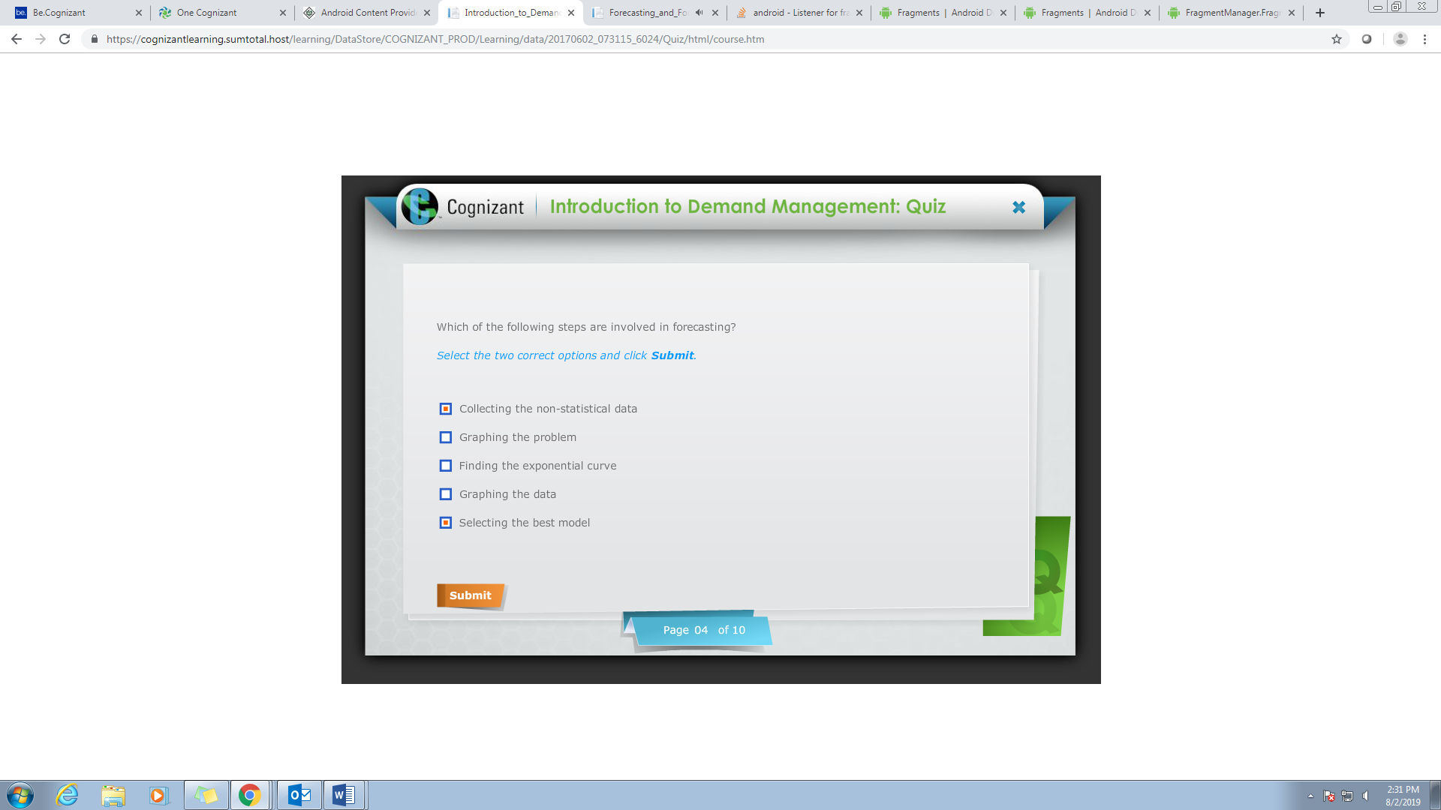

Option 4 & option 5 are correct

Q5

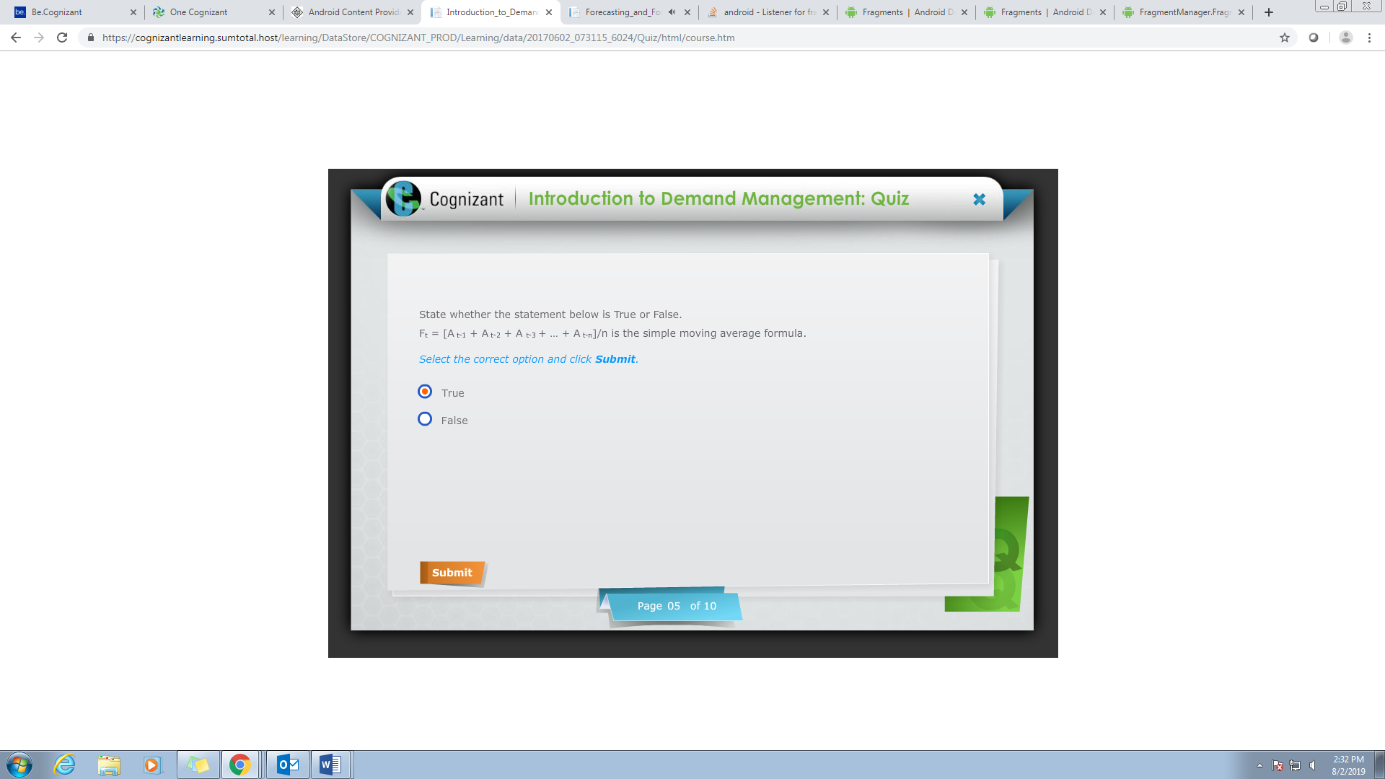

Q6

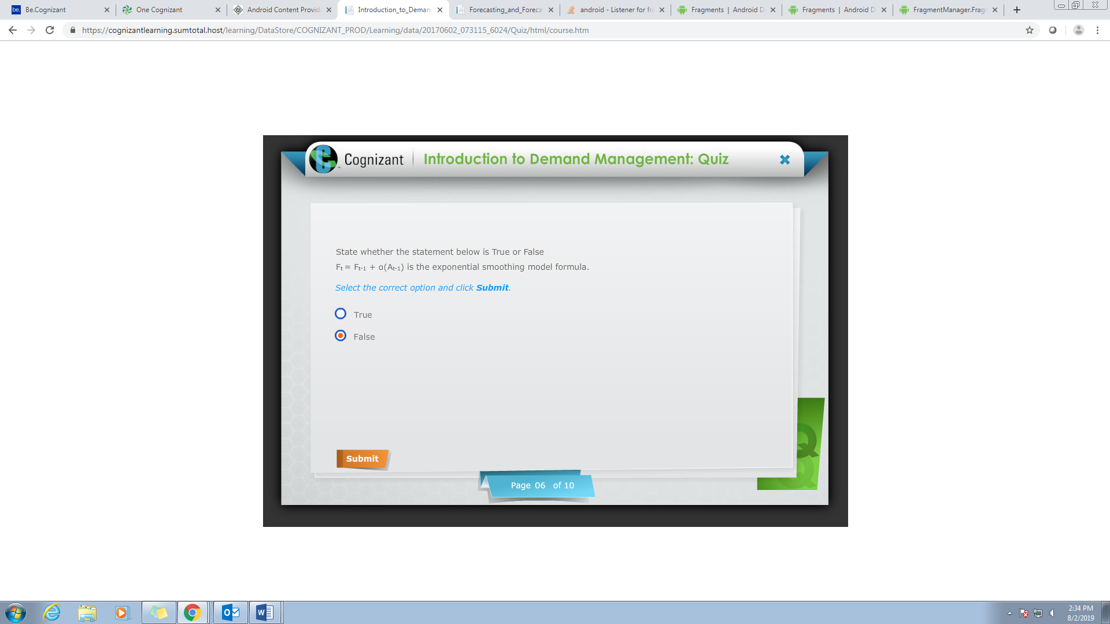

Q7

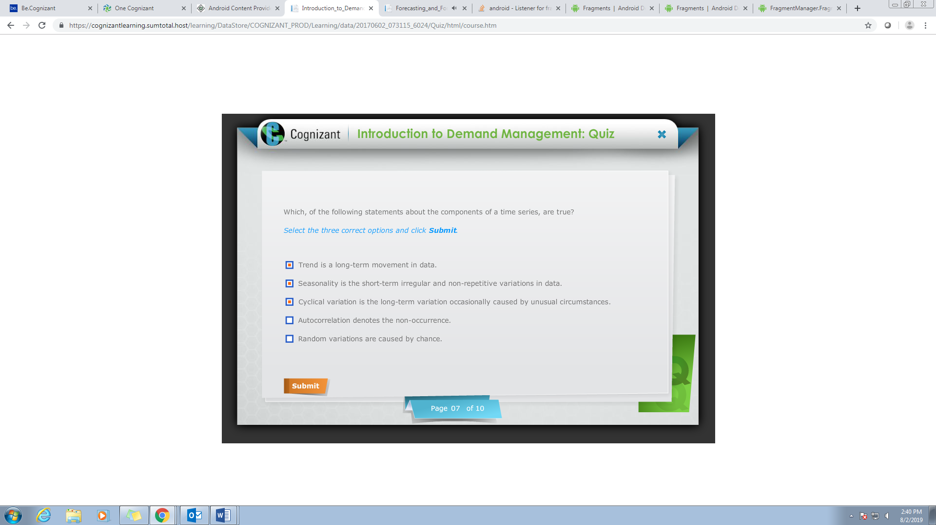

Q8

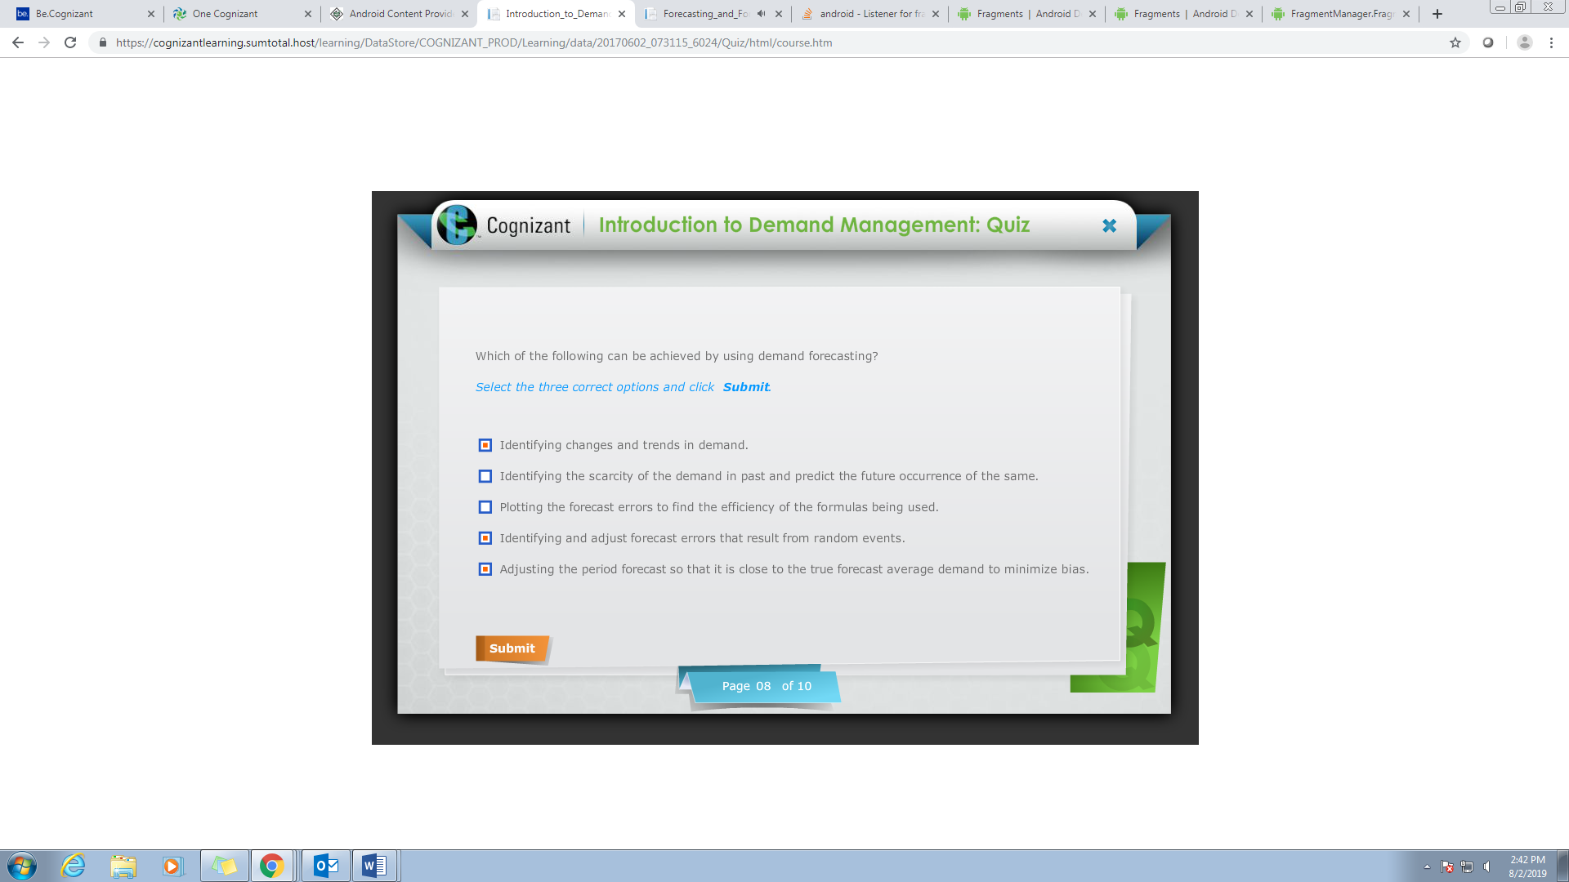

Q9

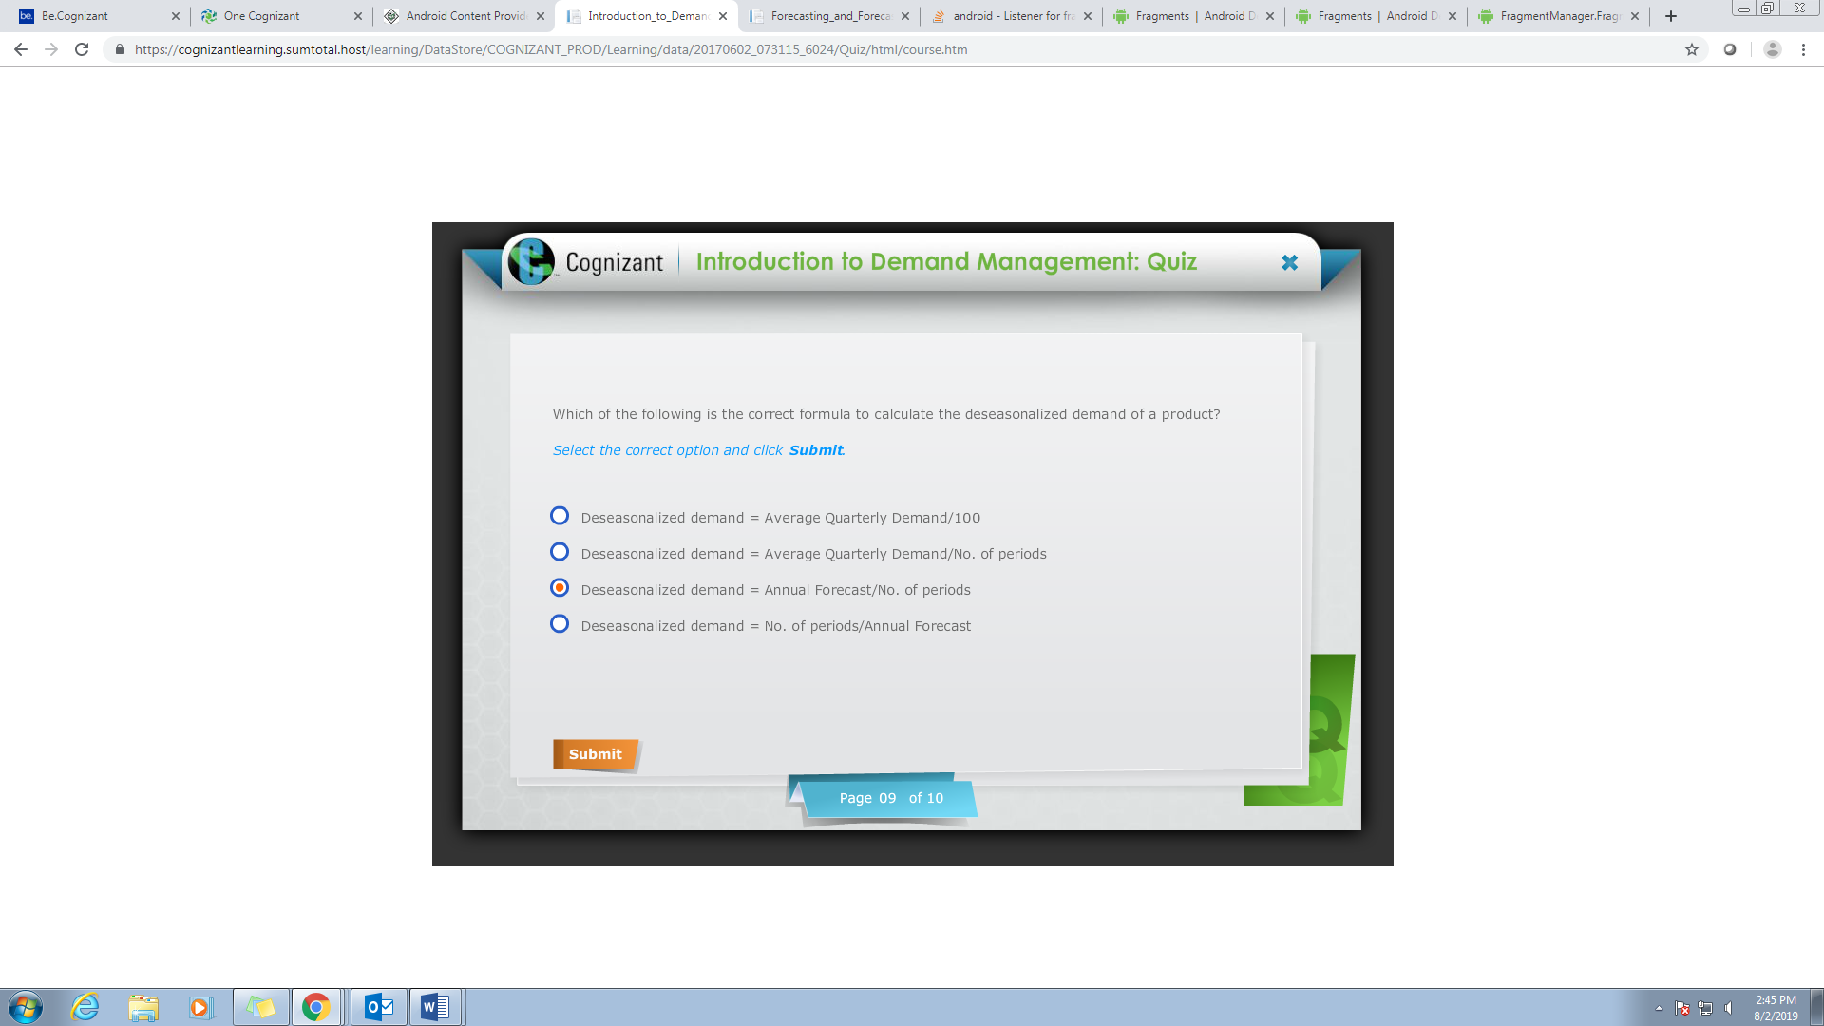

Q10

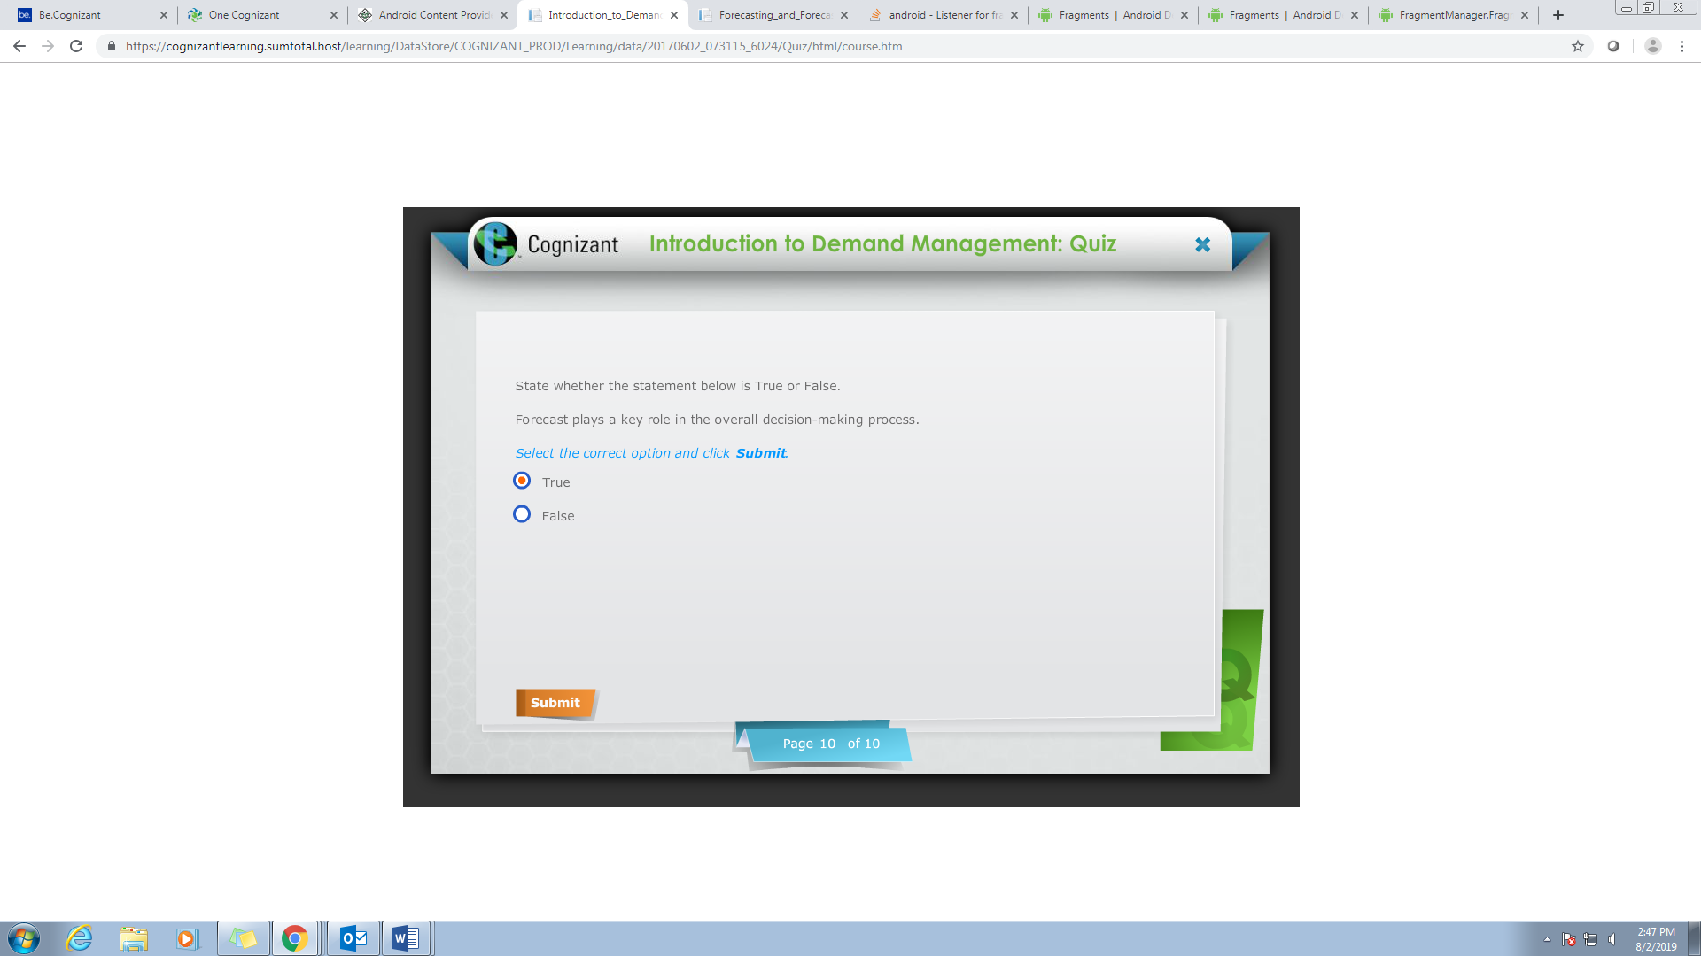

SUPPLY CHAIN MANAGEMENT

Q1

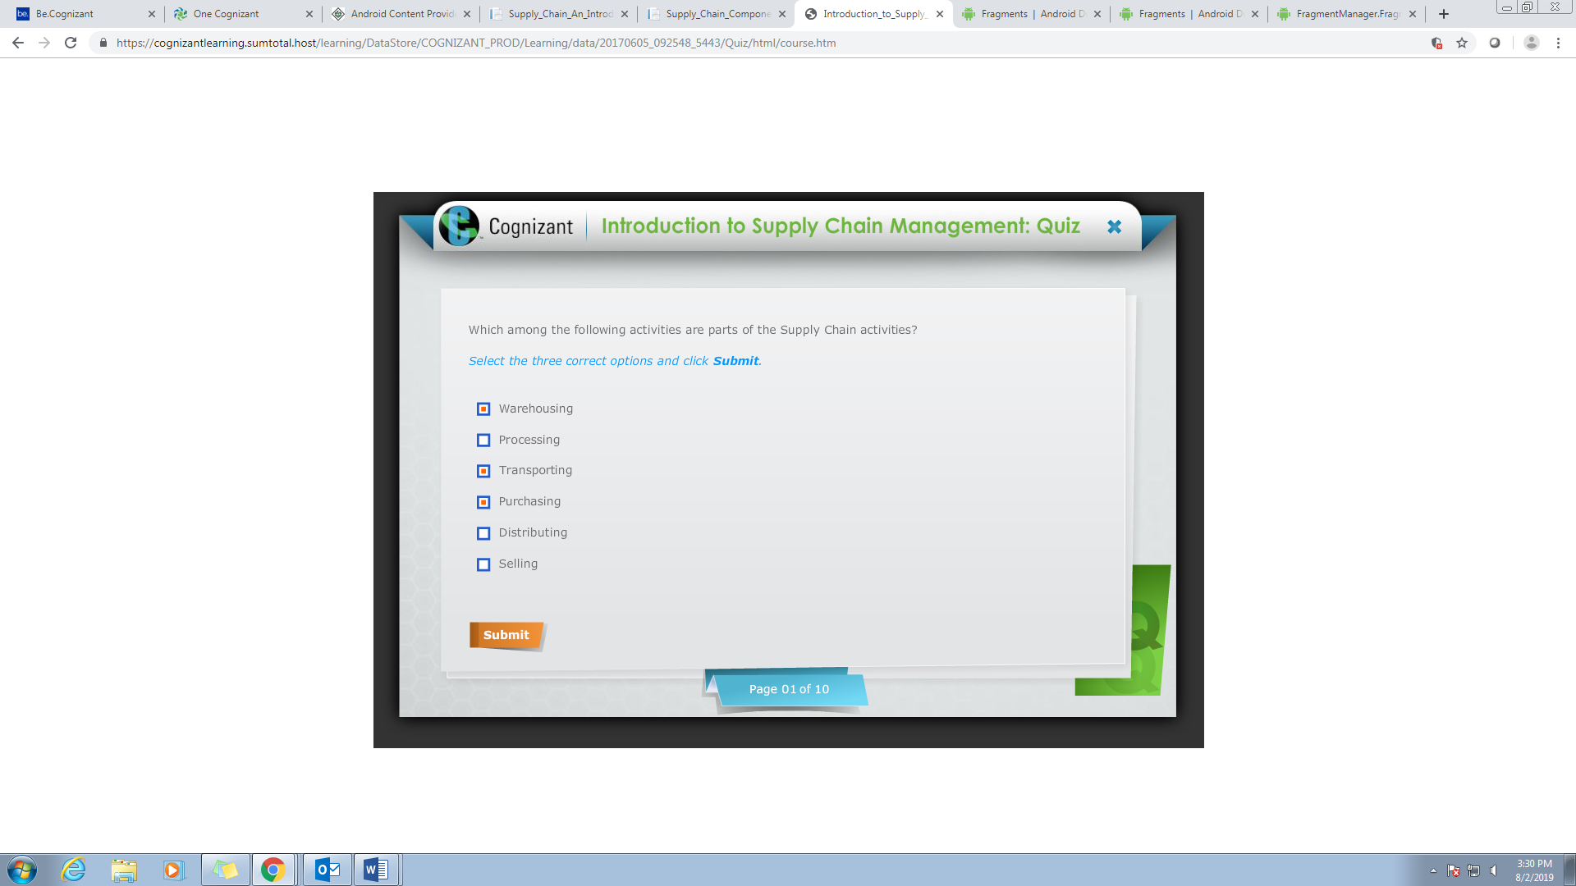

Q2

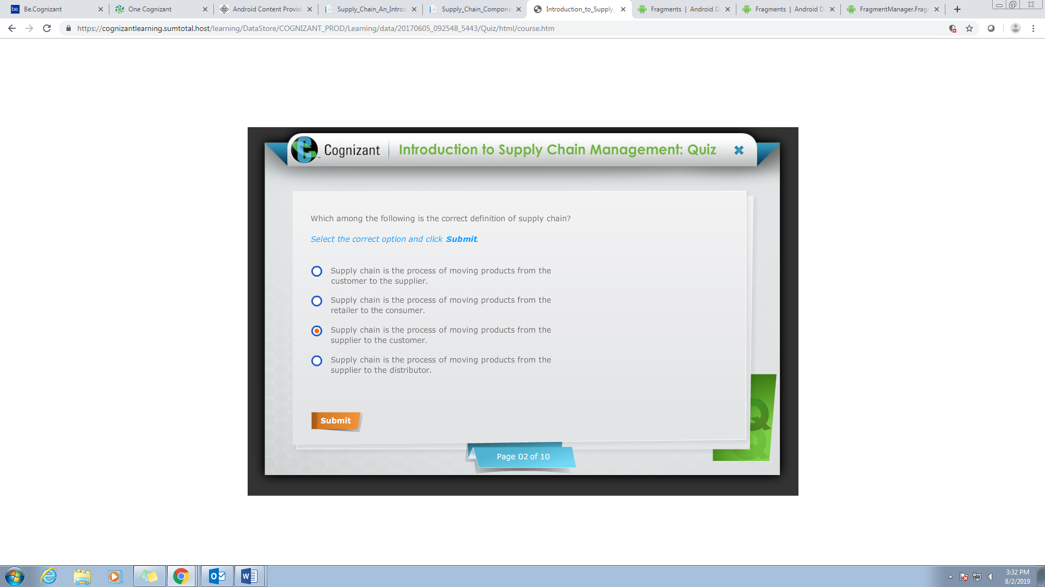

Q3

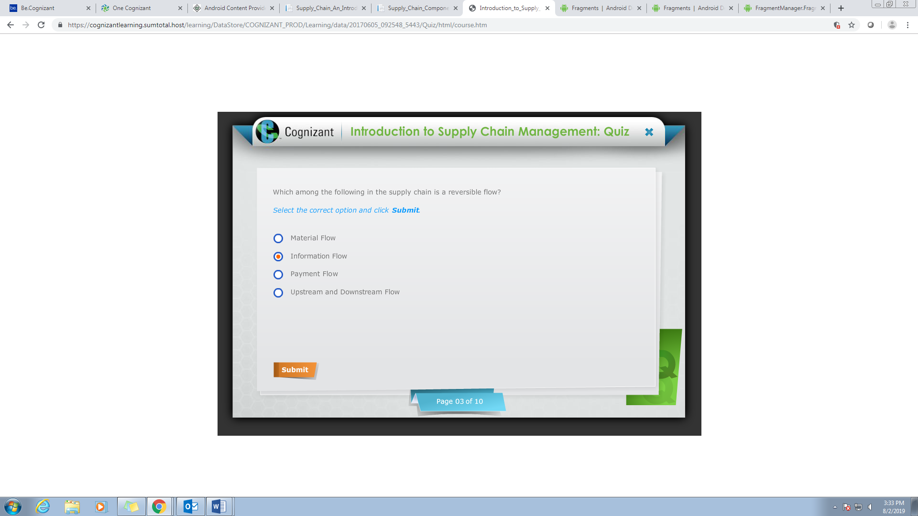

Q4

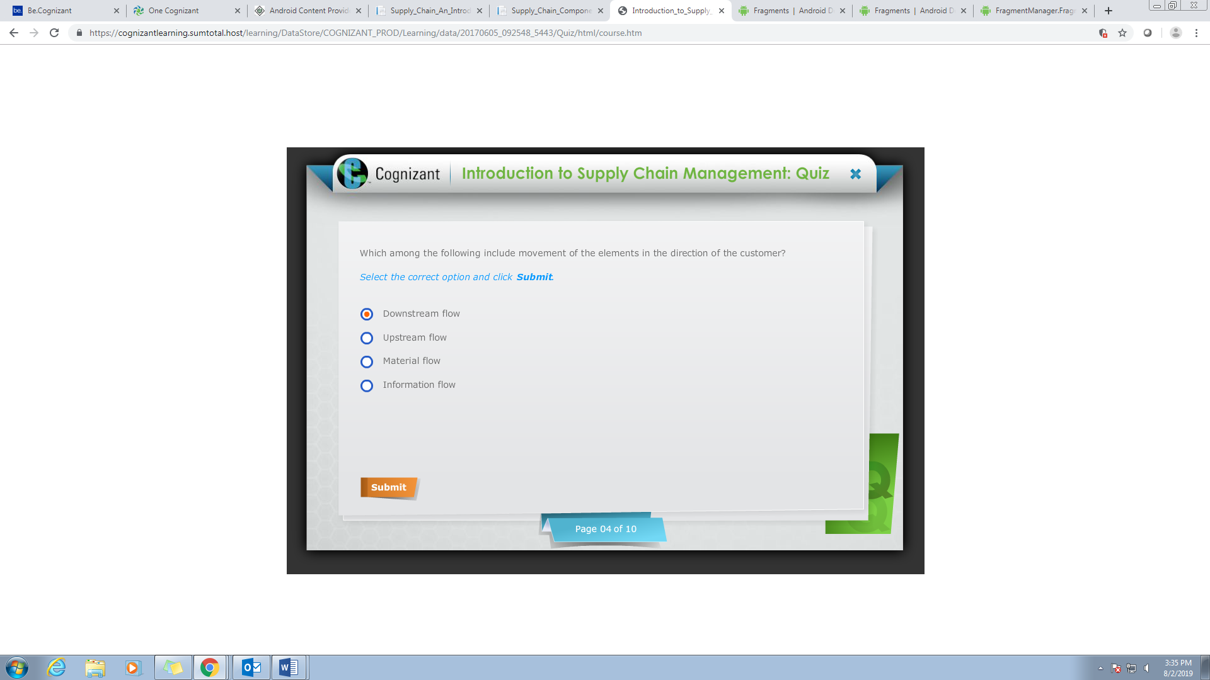

Q5

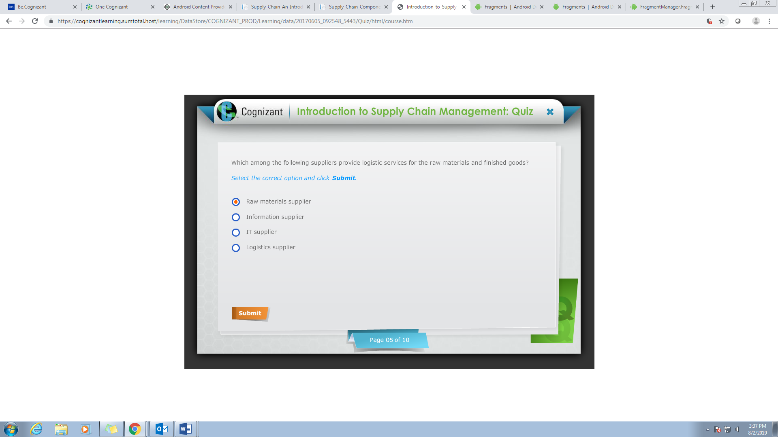

Q6

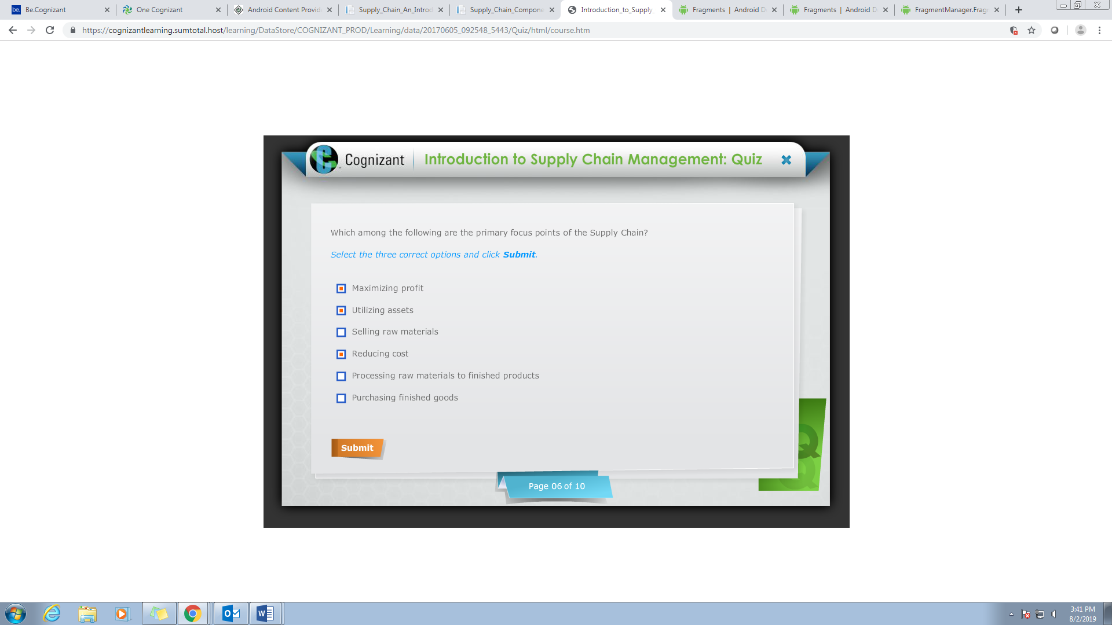

Q7

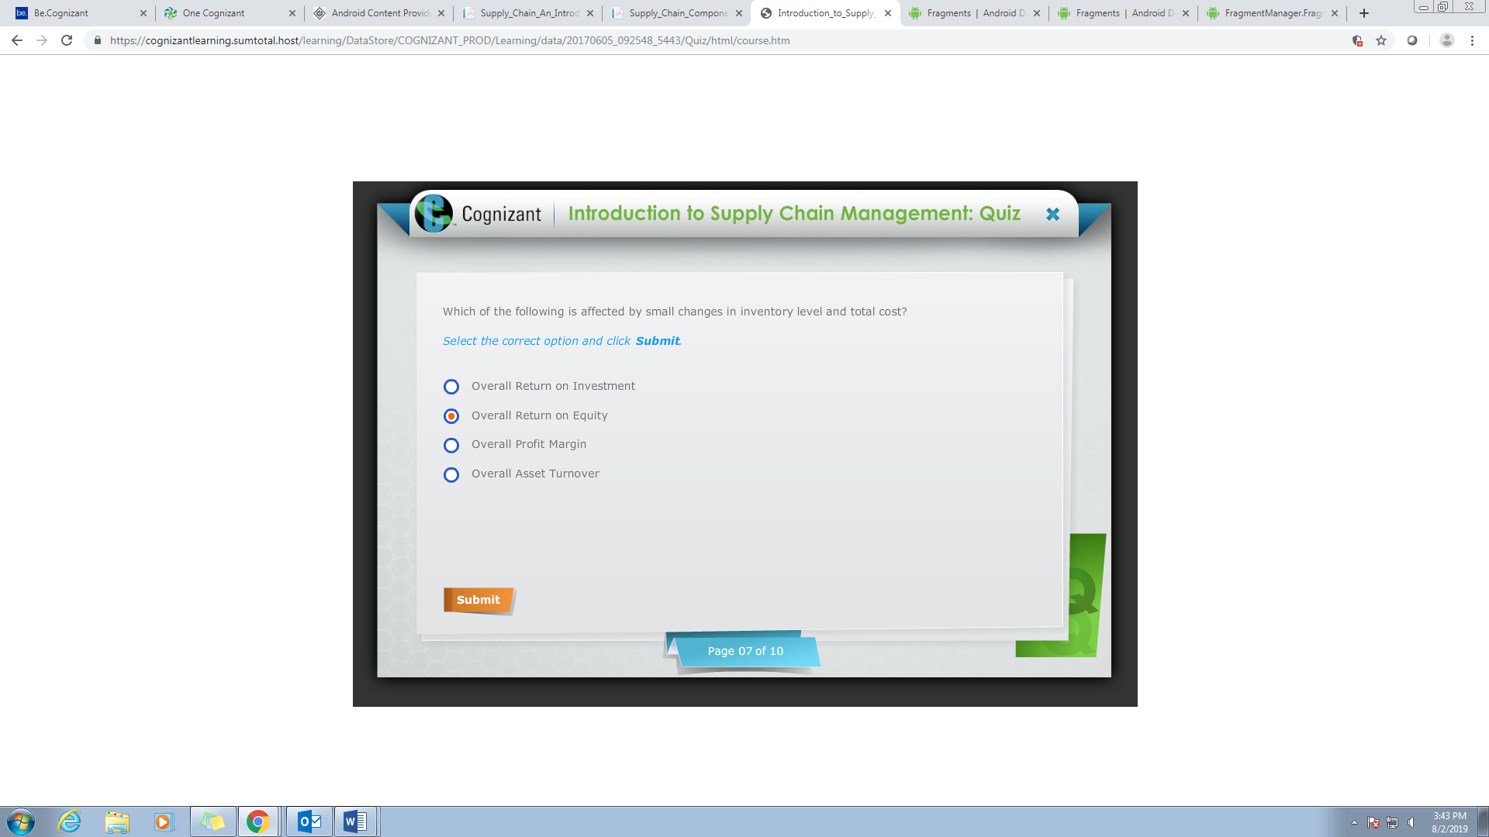

Q8

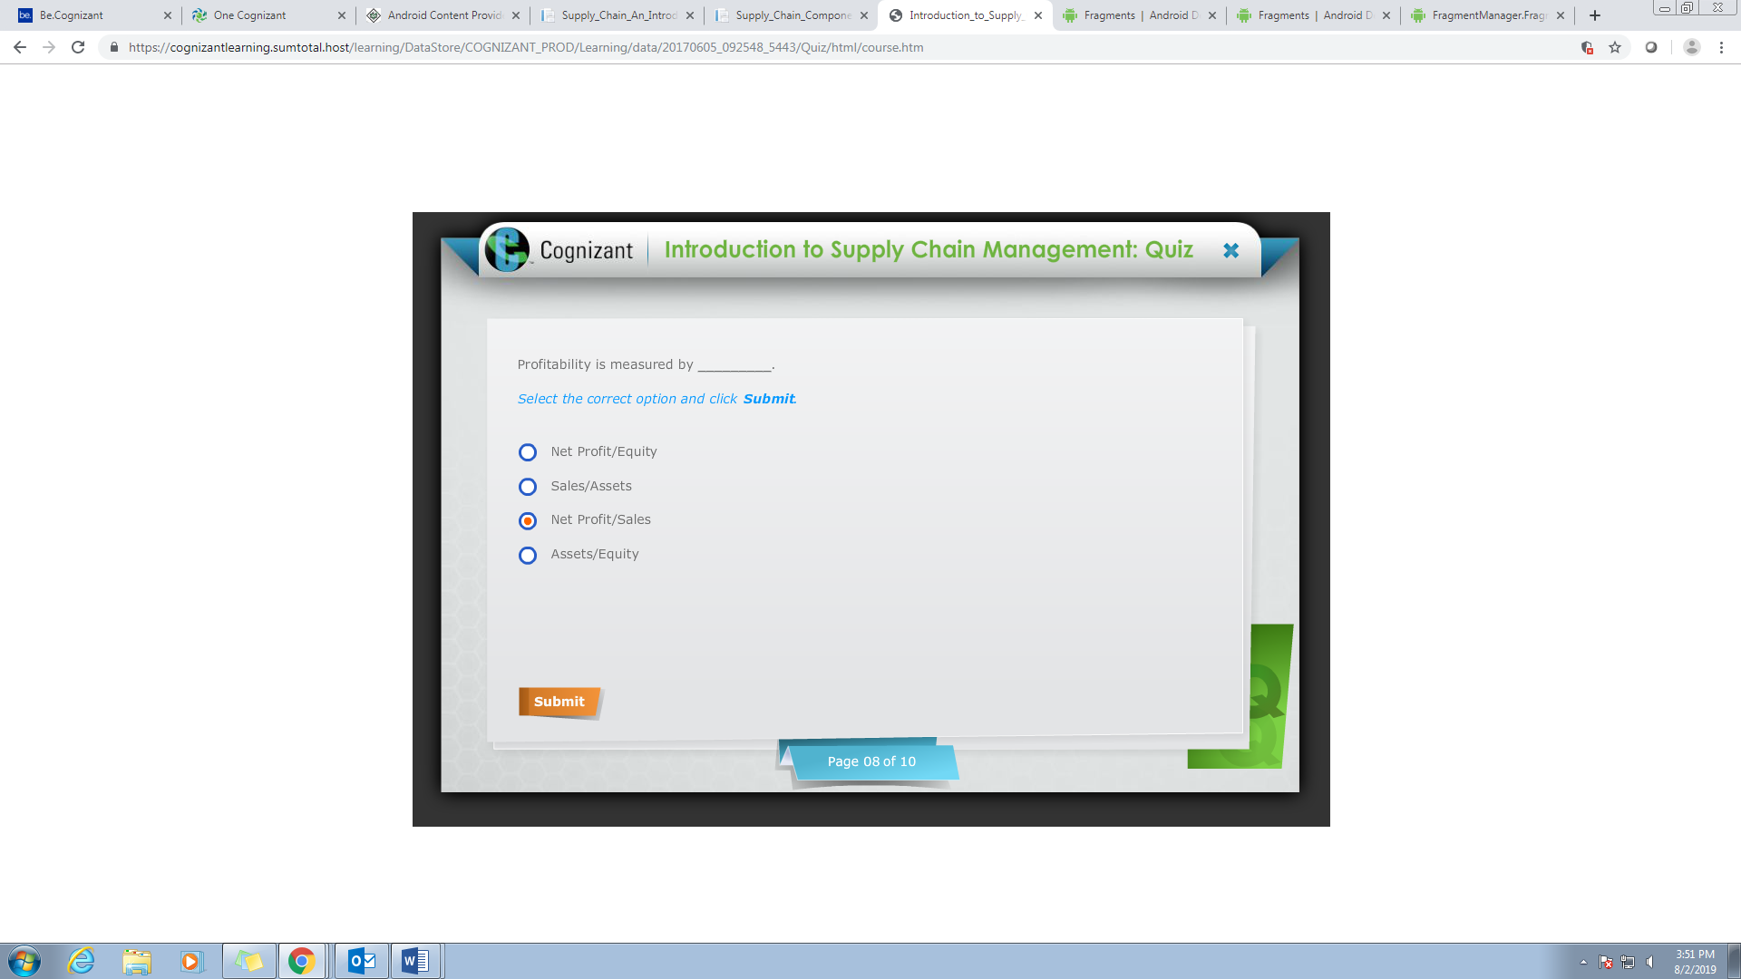

Q9

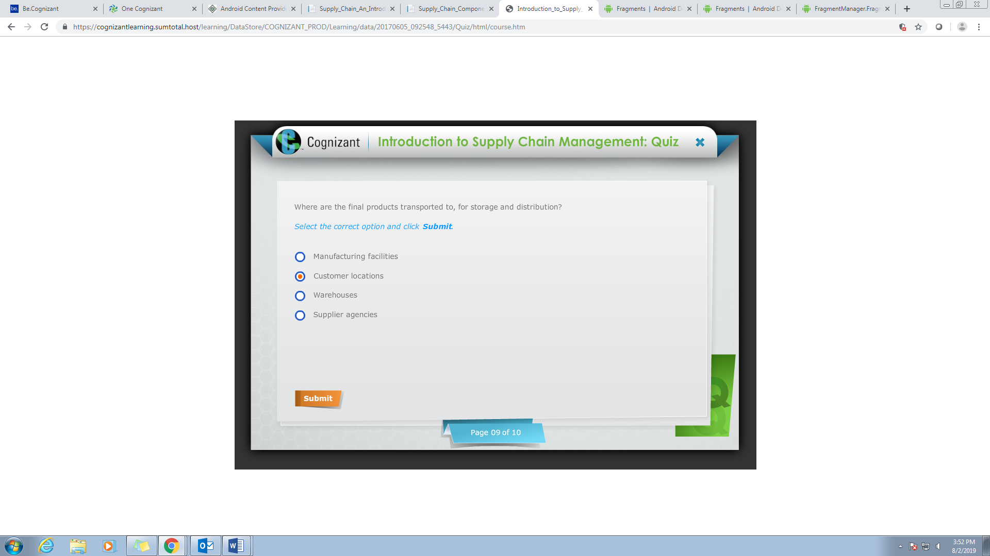

Warehouse

Q10

Capacity,Market, Demand

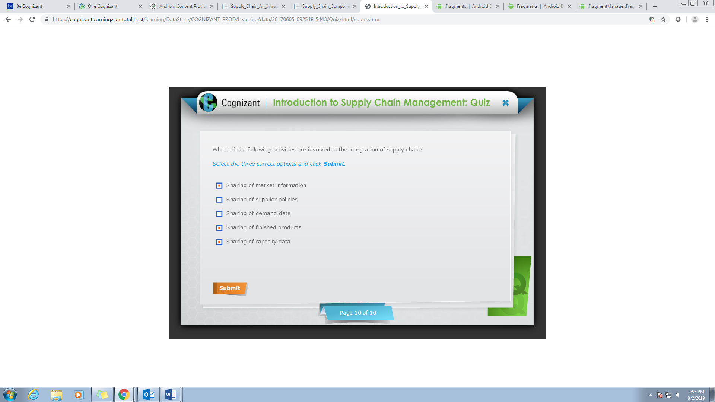

TRANSPORT MANAGEMENT

Q1

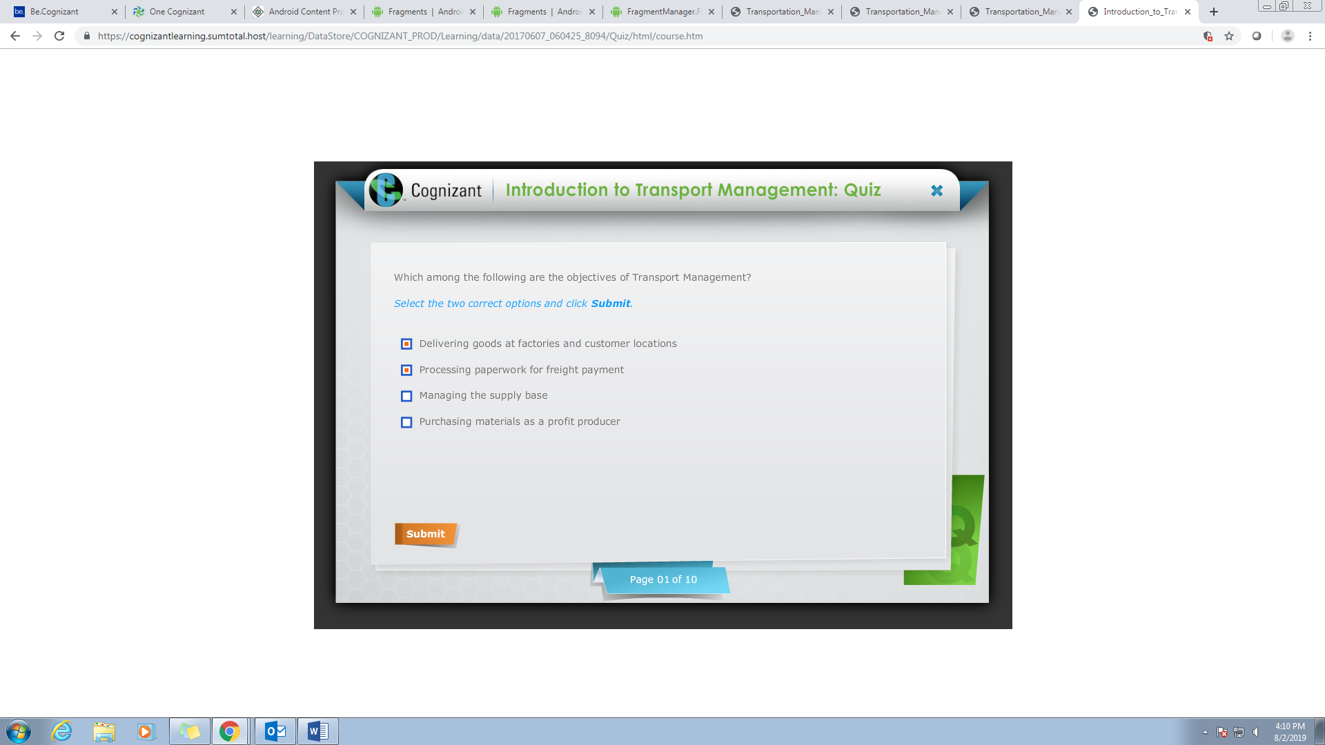

Q2

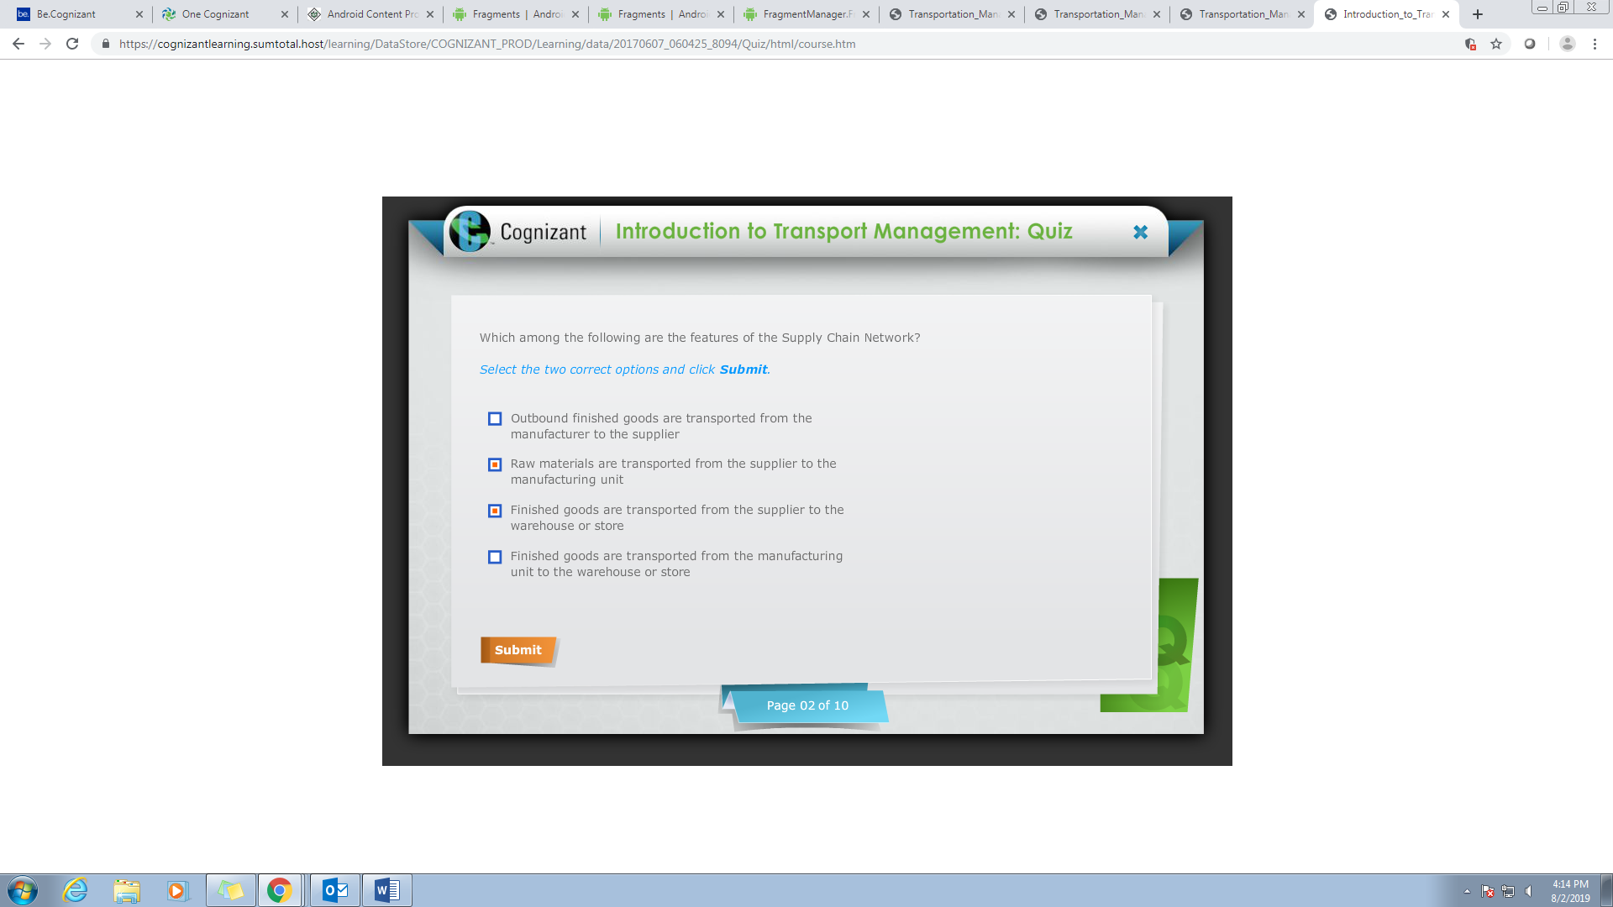

2 & 4 options

Q3

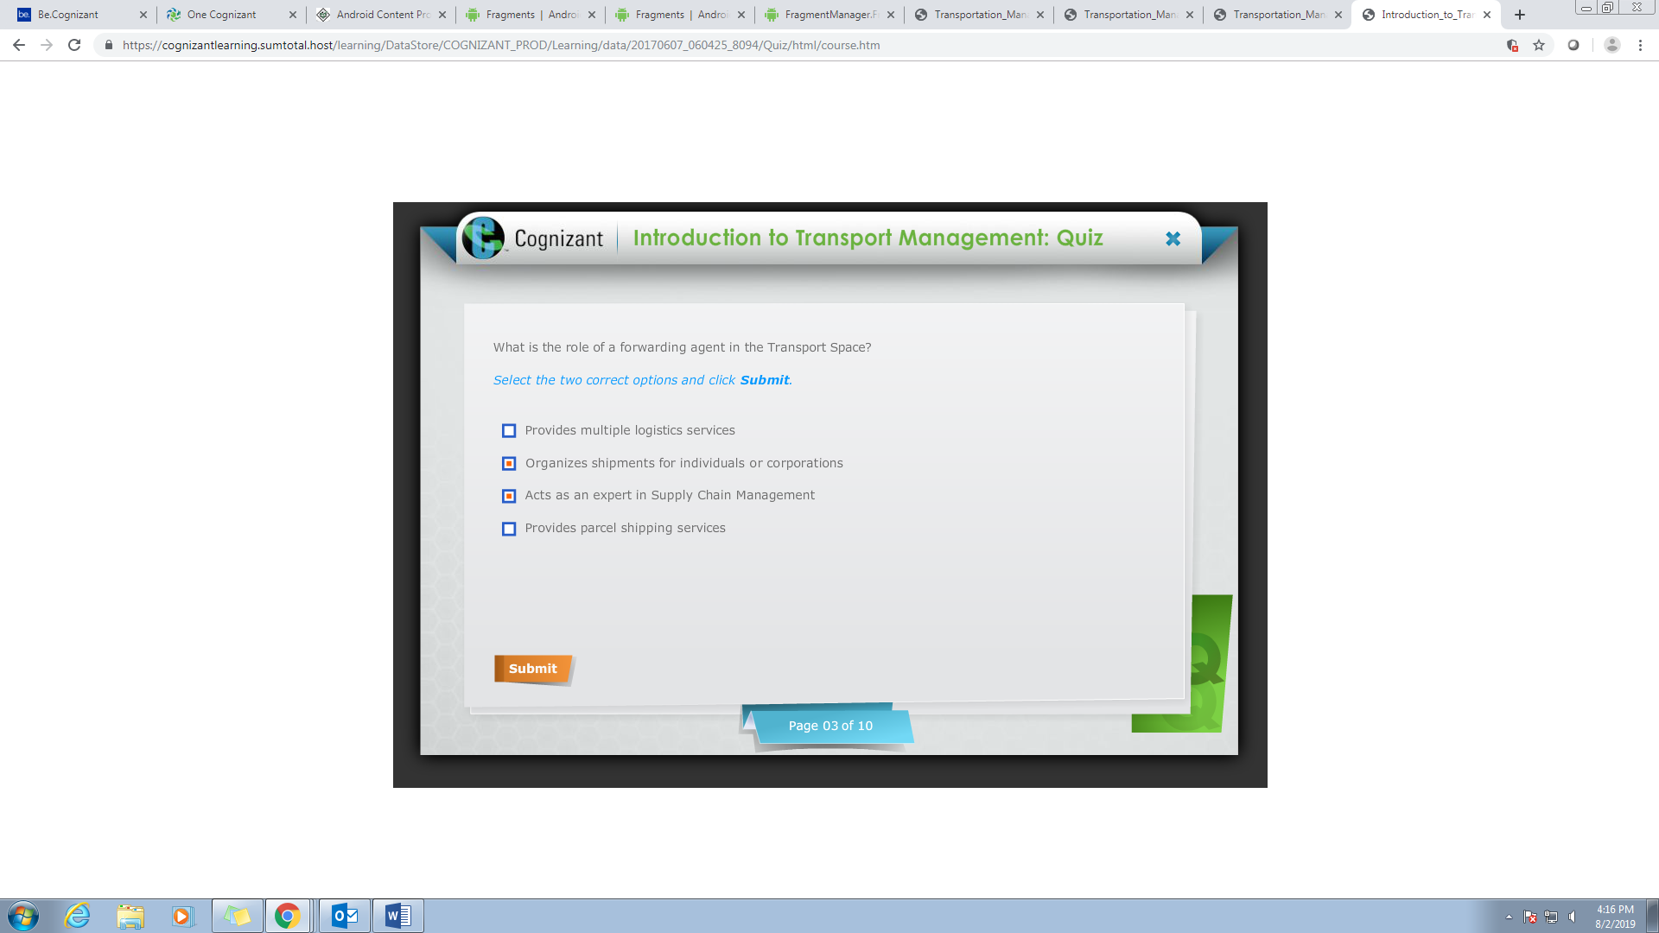

Q4

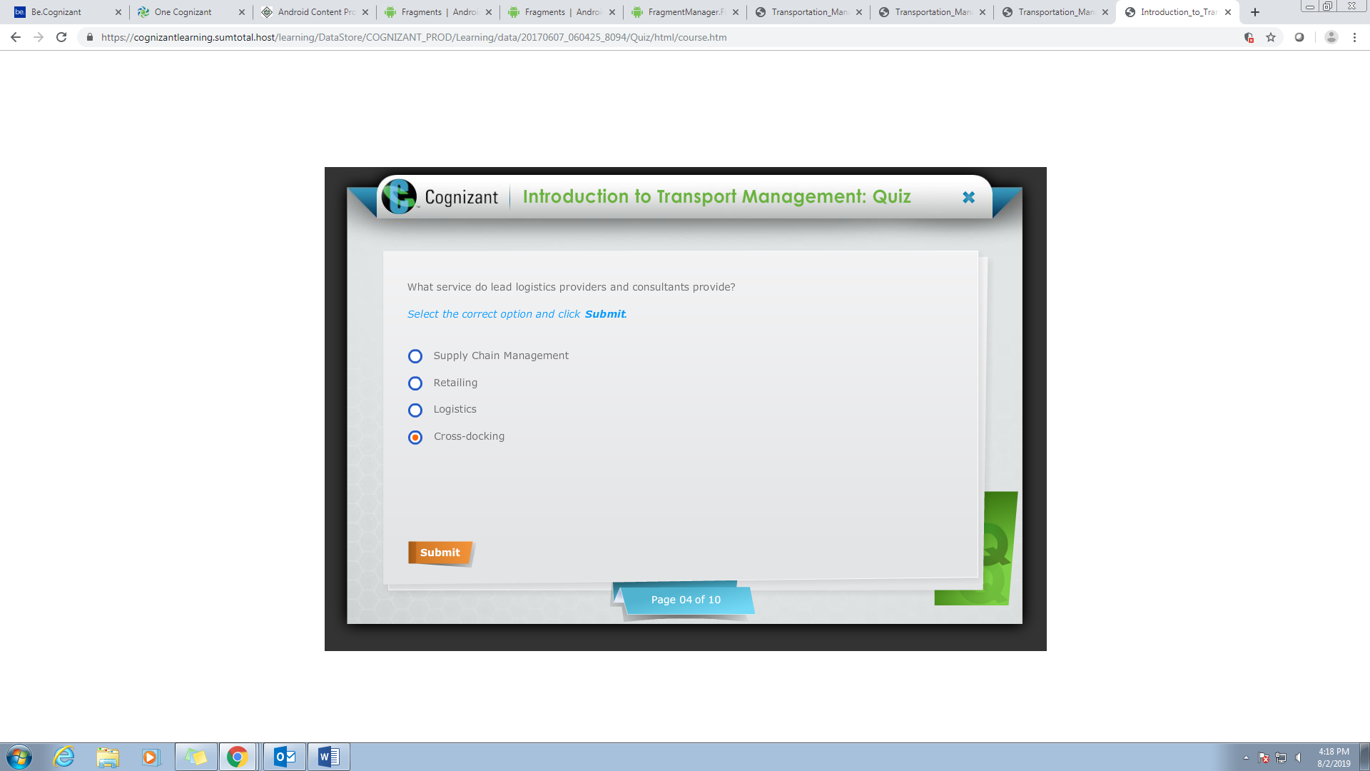

Supply Chain Management

Q5

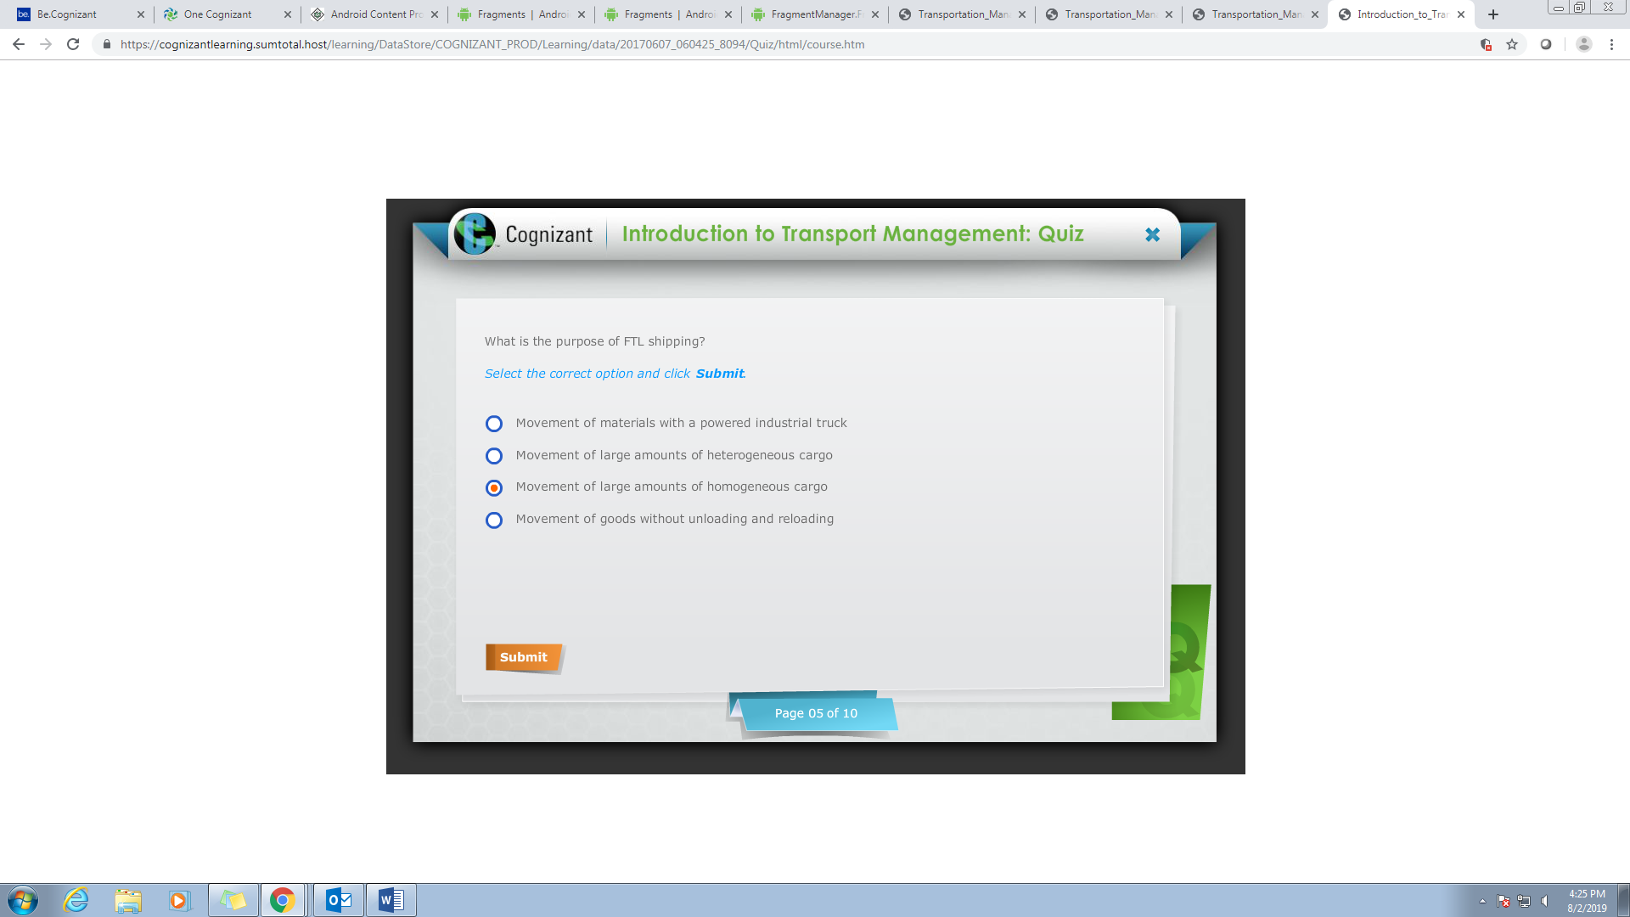

Q6

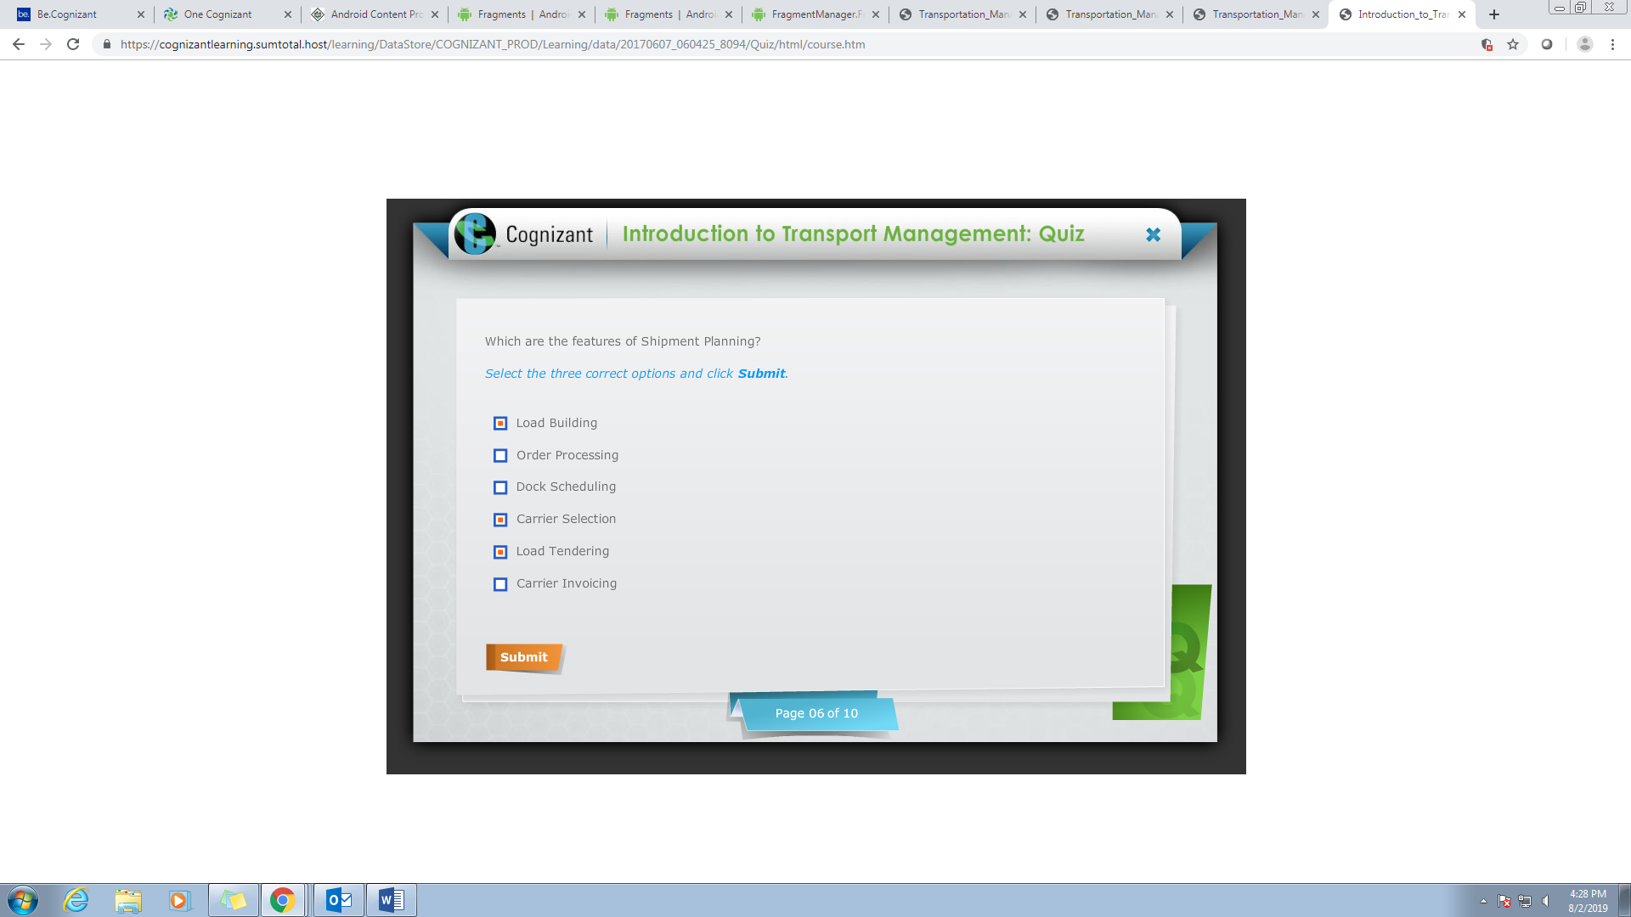

Q7

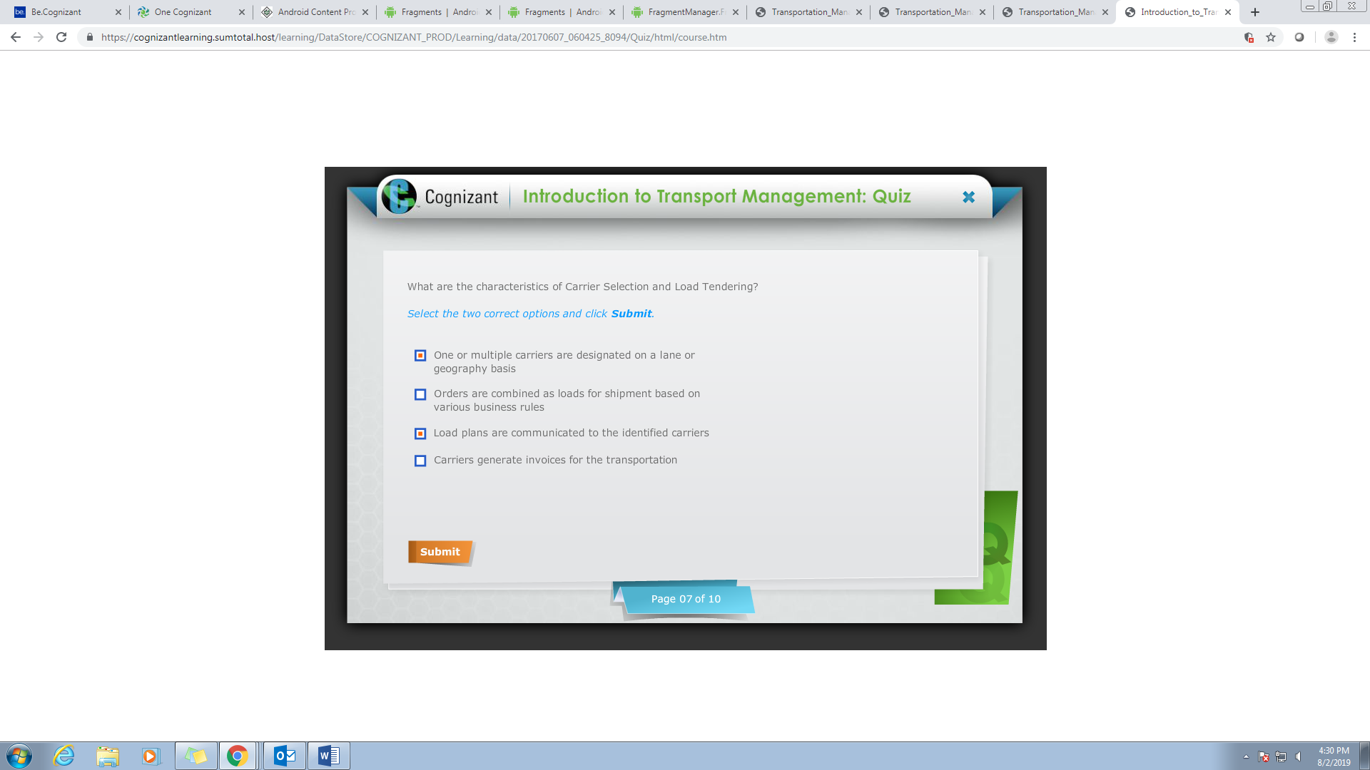

Q8

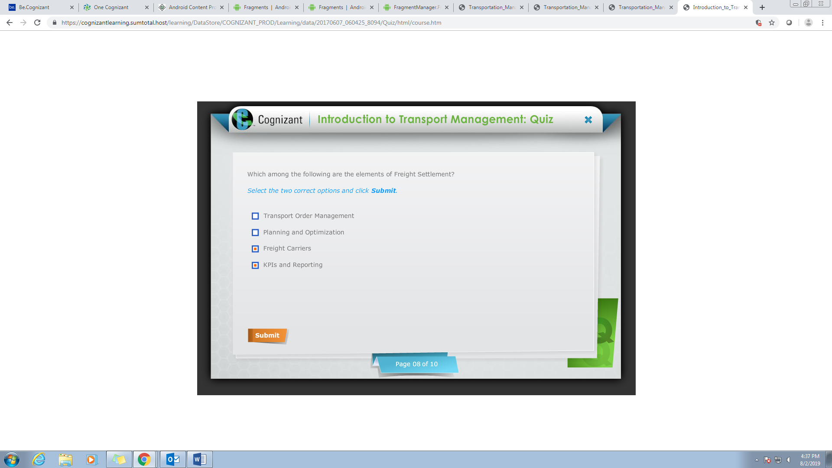

1 & 2 options

Q9

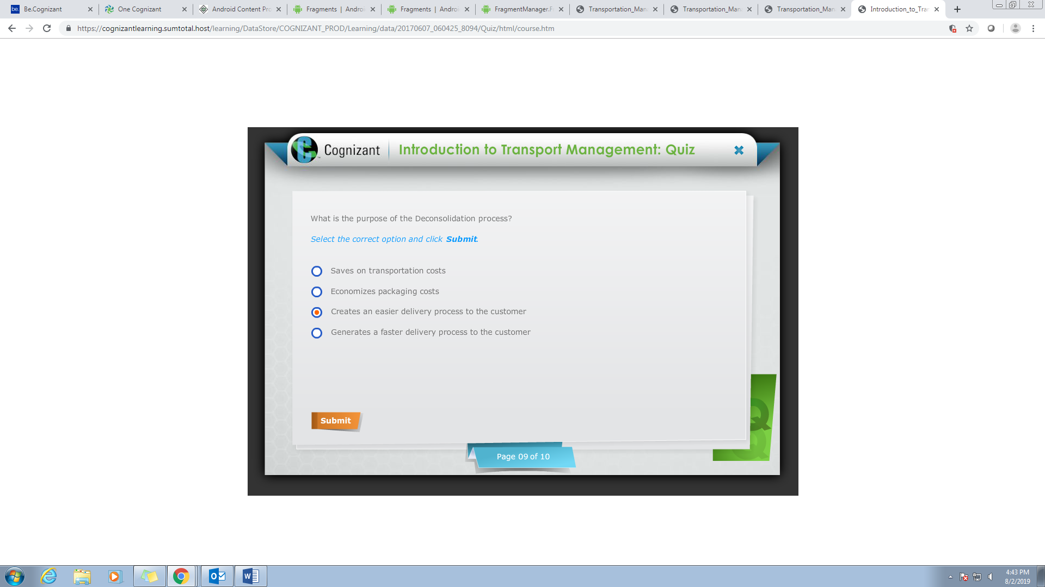

Q10

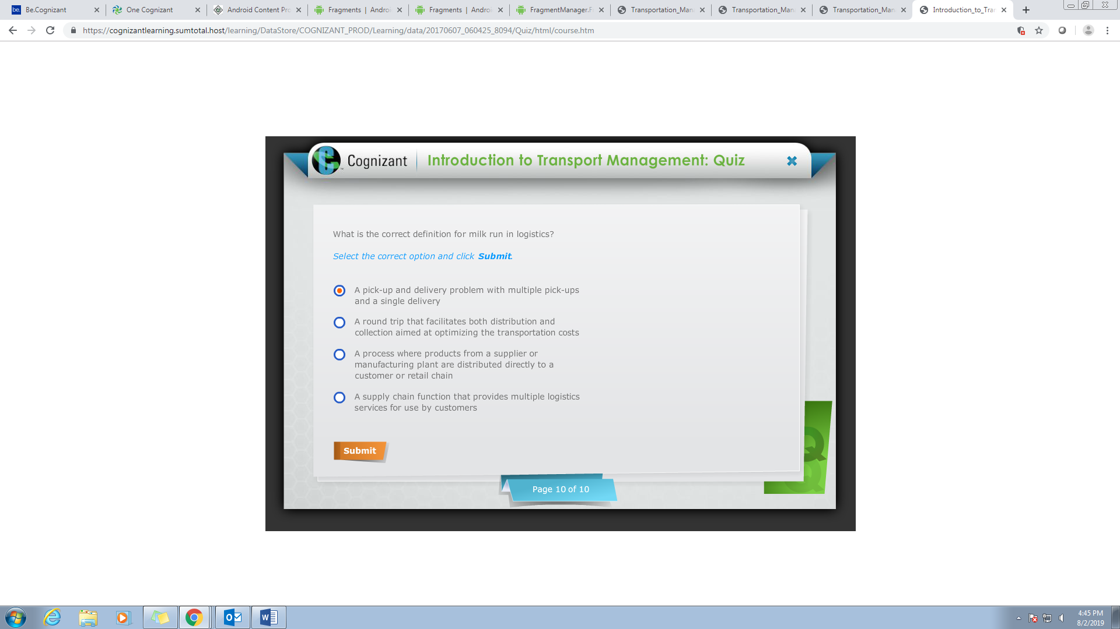

Second options